COMPLIANCE REPORT AND MANDATORY DISCLOSURE

Format for Mandatory disclosure Updated on 15.12.2012
1. AICTE File No. : 730-52-002(P)/ET/52
Date and Period of Last approval : 10.05.2012&F.No. SOUTHERN/1-716264122/2012/EOA/2012-2013
2. Name of the Institution : ADHIPARASAKTHI COLLEGE OF PHARMACY
Address of the Institution : ADHIPARASAKTHI COLLEGE OF PHARMACY
Melmaruvathur - 603 319
KANCHEEPURAM DISTRICT,
TAMILNADU,
TEL: 044-27529093
FAX : 044-27529196: Email:pharmacymlmr@gmail.com
Website : http://www.apcp.in

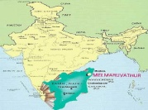
City and Pincode : Melmaruvathur & 603 319
State/UT : TamilNadu
Longitude & Latitude : 79 deg 48 min & 12 deg 25 Min
Phone No with STD Code :044 -27529093
Fax Number with STD Code : 044 – 27529196
Office Hours at the Institution : 8.30 AM to 5.30 PM
Academic Hours at the Institution : 9.15 AM to 4.45 PM
E-mail : pharmacymlmr@gmail.com
Website : http://www.apcp.in
Neareast RailwayStation (dist in km) : Melmaruvathur Railwaystation (2 km)
Nearest Airport : Meenampakkam, Chennai (91 km)
- Type of Institution : Private self financed
Catagory (1) of the Institution : Non Minority
Catagory (2) of the Institution : Co-Ed
- Name of the Organization running the institution : Adhiparasakthi Charitable, Medical , Educational and
Cultural Trust
Type of the Organization : Trust
Address of the Organization : Adhiparasakthi Charitable, Medical, Educational and
Cultural Trust, Melmaruvathur – 603319, Kancheepuram District.(TN).
Registered with : Chengalpet
Registration Date : 20.10.1978
Website of the Organization : http://www.omsakthi.org

- Name of the Affiliating University : THE TAMIL NADU Dr. M.G.R. MEDICAL UNIVERSITY, CHENNAI
Address : THE TAMIL NADU Dr. M.G.R. MEDICAL UNIVERSITY
No. 69 , Anna Salai, Guindy , Chennai -600 032
Website : http://web.tnmgrmu.ac.in
Latest affiliation Period : 2012-2013
- Name of the Principal/Director : Dr. T. VETRICHELVAN
Exact Designation : Professor and Principal
Phone No with STD Code : TEL.:044-27529093, MOBILE : 09443010858
Fax NO. With STD Code : FAX: 044-27529196
E – Mail : vetrisel@yahoo.com
Highest Degree : Ph.D
Field of Spécialisation : Pharmaceutical Chemistry/Analysis

- Governing Board Members :

Sl. No. | Name | Academic Qualification |  | Nature of Association with the Promoting Body | Experience in Academic Institutions  (in Years) |  |  | Overall  Experience  (in Years)
Sl. No. | Name | Technical | Non Technical | Nature of Association with the Promoting Body | Promotional | Management | Organis  ational | Overall  Experience  (in Years)
1 | Mr.G. Bangaru Adigalar | --- | Teacher | President |  | Management |  | 42
2 | Mrs.V.Lakshmi | --- | Teacher | Vice President |  | Management |  | 42
3 | Dr.T.Ramesh | Doctor | -- | Managing Director |  | Management |  | 12
4 | Mrs. B.UmaDevi | Pharmacist | -- | Correspondent |  | Management |  | 09
5 | Mr.R.Karunanithi | ------ | Economist | Secretary | Promotional | Management |  | 25
6 | Mr.A.V.Venkatasamy | ------ | Sociologist | Treasurer | Promotional

Frequency of Meetings & date of Last meeting : Every Six Months & 27.11.2012

- Academic Advisory Body :
Chairman : Dr. T. Vetrichelvan, Principal
Member : Dr. S. Kavimani, MTIHS, Pondicherry
Member : Dr.M. Jegadeesan, Tamil University, Thanjavur
Member : Dr. K. Valliappan, Annamalai University
Member : Dr.K. Ilango, SRM University
Member : Dr. K. Rajasekaran, KMCH, Coimbatore.
Frequency of Meetings & date of Last meeting : Every Six Months & 08.12.2012

- Organisational Chart : Organizational chart and processe

Illustration of organization chart showing pattern of decentralization

Founder President
Authority on major policy decisions and review

Vice – President
Authority on implementation of major policies including financial matter

Correspondent
Bridge between the Vice- President and the Secretary

Secretary
Authority on speeding up the implementation of major decisions

Principal
Academic authority of the institution including general administration

Vice – Principal
academic authority of the institution including the general administration in the absence of the principal
Superintendent
Office supervision
Maintenance Officer
Maintenance of the campus

HODs
academic authority of the concerned department

Faculty  Final execution of the special tasks |  | Technical Staff  Lab Maintenance

Student feedback mechanism on Institutional Governance/faculty Performance :
Periodical collection of feedback on academic/hostel facilities from respective students and will be reported to the concerned authorities for day to day development of infrastructural facilities.
- Grievance redressal mechanism for Faculty, Staff and Students :
Once in three months suggestions received from faculty, staff and students for the implementation of their desire to uplift this technical institute.
- Name of the Département :
Pharmaceutical Sciences (UG), (PG)-Pharmaceutical Analysis, Pharmaceutics & Pharmaceutical Chemistry)
Developing programs, in accordance with AICTE, PCI and University guidelines, that leads to the B.Pharm. and M.Pharm.
Degree courses.

Courses : B. Pharmacy, M.Pharmacy & Ph.D
Level : U.G, P.G. & Ph.D.
1 st year of approval by the council : 31.03.1994

S.No | Course | Year/  Session | Year wise  Sanctioned Intake | Year wise  actual  Admission | Cut off marks- General quota |  | Session | % Students passed with distinction | % Students passed with first class | Students placed | Average pay package Rs/year | Students opted for higher studies
1 | B.Pharm | 10-11 | 60 | 30 | Govt  162.00 | CET  83.00 | Aug 2010 | 18 | 54 | 33 | 28000 | 14
2 | B.Pharm | 11-12 | 60 | 44 | 92.75 | 83.00 | Aug 2011 | 23 | 51 | 27 | 28000 | 10
3 | B.Pharm | 12-13 | 60 | 54 | 111.00 | 87.50 | Aug 2012 | 33 | 58 | 11 | 28000 | 10
4 | M.Pharm | 10-11 | 18+18+10 | 17+18+10 | 39.60+40.32+35.28 | 23.32+28.36+29.08 | Mar 2010 | 58+80 | 42+20 | 12 | 57000 | 02
5 | M.Pharm | 11-12 | 18+18+10 | 4+14+1 | 37.00+35.40 | 53.08+53.08+61.72 | May 2011 | 92+100+  100 | 8 | 12 | 57000 | 02
6 | M.Pharm | 12-13 | 18+18+10 | 3+2+0 | --- | 41.76+40.64 | May 2012 | 100+70+90 | 20+10 | 10 | 57000 | 01

Accreditation Status of the course : Not Accredited BY AICTE, BUT ACCREDITED BY NAAC
Doctoral Courses : Yes, Ph.D. ( Pharmaceutical Analysis)
Foreign collaborations, if any : NIL
Professional Society Memberships : IPA, IPGA, APTI
Professional activities :

1. Conducting regular seminars, workshops and symposium
2. Encouraging the students to attend national seminars and also to publish the project work in National
and International Journals
3. Recruiting the staff to do their higher education and to attend QIP program, national and international
Seminars
4. Conducting EYE camp and awareness programs related to AIDS, DIABETES etc.,

Consultancy activities : Stability studies and Quality control Studies of Herbal
Formulations as per FDA Requirements
Grants fetched : Utilization status of grants received under various schemes of AICTE

MODROB, Faculty development, IIPC etc for the last three years).

S.No | Name of the Scheme(s) |  | Grant sanctioned (Amount & Date) | Grant utilized | Whether utilization certificate submitted, if yes amount for which submitted | Major impact
1. |  | Staff Development Programme | 4,20,000 | 3,44,323 | 3,44,323 | Tools for the design and validation of analytical methods

Departmental Achievements :
- Strength of the Institution for Teaching Methodology
- Each department procured the necessary facilities such as OHP, Projector and LCD for routine classes as
well as for periodical seminars.
- Every year two seminars on Recent Trends in Pharmacy is conducted and highly useful for Final year UG & PG
students.
- By interacting industrial pharmacist, newer formulations and analytical studies were performed and published the conclusion drawn in leading journals.
- Friendship Association of India, New Delhi, Honored our faculties as a “Best Citizenship of India” award for the
research work, particularly in the studies of finger prints with FTIR, HPLC and UV-Visible Spectroscopy.
- The Tamilnadu Dr.M.G.R. Medical University also honored Best Teachers Award to our faculties and recognized their contribution for the profession of Pharmacy.
Distinguished Alumni:
1. Gurumoorthy-scientist, Germany
2. Dinesh Babu-scientist, U.K.
3. S.V.Rani-Junior research scientist, U.K
4. Sajeli Bagum-Lecturer, Banarus Hindu University, Varanasi
5. Balaji- Research Associate, Orchid chemicals, Chennai
6. Anitha- Research Associate, Orchid chemicals,
7. Ramvignesh-Research Associate, Reddy’s Laboratory, Hyderabad.

13. TEACHING STAFFS

FACULTY PROFILE- Dr. T. Vetrichelvan
Name of Teaching Staff | Dr. T. Vetrichelvan |  | 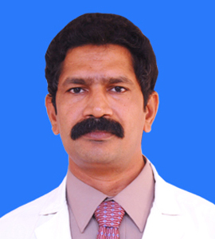
Designation | Principal and Professor
Department | Pharmaceutical Analysis
Date of joining the institution | 02.11.1995
Qualifications with Class / Grade  Did All Programs in  Government Institutions/  Government University | UG  B.Pharm  First Class  (MMC, Madurai) | PG  M.Pharm  First Class with Distinction  (JU, Kolkatta) | Ph.D.  Core Subjects in Pharmacy  (Tamil University)
Total Experience in years | Teaching  20 | Industry  04.0 | Research  14
Papers Published | National  45 | International  10
Papers Presented in Conferences | National  18 | International  05
Ph.D Guide? Give field & University | Field  Pharmaceutical Analysis  Pharmaceutical analysis and interdisciplinary | University  The Tamilnadu Dr.M.G.R Medical University, Chennai  Annamalai University  SASTRA University
Ph.Ds / Projects Guided | Ph.Ds  12 | Projects at Masters Level  25
Books Published/ IPRs/ Patents | 01/ Partly published
Professional Memberships | APTI, IPA and IPGA
Consultancy Activities | Stability and evaluation studies of Herbal preparations-Murmak Pharmaceuticals, Thanjavur
Awards | Best citizen of India by Friendship Association, New Delhi,  Best Teacher Award given by The Tamilnadu Dr.M.G.R Medical University,Chennai.
Grants fetched | SDP etc.
Interaction with Professional Institutions | Department Of Herbal Science, Tamil University  SASTRA University  SRM University

FACULTY PROFILE- Prof.. K. Sundaramoorthy
Name of Teaching Staff | Prof. K. Sundaramoorthy |  | 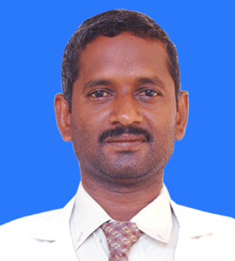
Designation | Professor
Department | Pharmaceutics
Date of joining the institution | 25.08.96
Qualifications with Class / Grade | UG  B.Pharm  Second class | PG  M.Pharm  First Class | Ph.D  ------
Total Experience in years | Teaching  16 | Industry  --- | Research  09
Papers Published | National  07 | International  01
Papers Presented in Conferences | National  ---- | International  -----
Ph.D Guide? Give field & University | Field  ---- | University  ------
Ph.Ds / Projects Guided | Ph.Ds  ---- | Projects at Masters Level  11
Books Published/ IPRs/ Patents | -----
Professional Memberships | APTI
Consultancy Activities | ------
Awards | Rs.2000/ cash award for paper publication in Pharma buzz journal.
Grants fetched | ------
Interaction with Professional Institutions | ------

FACULTY PROFILE- Ms. M. Sudha
Name of Teaching Staff | Ms. M. Sudha |  | 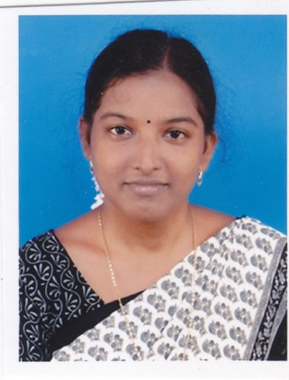
Designation | Asst Professor
Department | Pharmacology
Date of joining the institution | 09/08/2010
Qualifications with Class / Grade | UG  B. Pharm  First Class | PG  M.Pharm  First Class with Distiction | PhD  -----
Total Experience in years | Teaching  2 | Industry  01 | Research  0
Papers Published | National  01 | International  0
Papers Presented in Conferences | National  03 | International
Ph.D Guide? Give field & University | Field  ---- | University  ----
Ph.Ds / Projects Guided | Ph.Ds  ---- | Projects at Masters Level  0
Books Published/ IPRs/ Patents | ---
Professional Memberships | ----
Consultancy Activities | -----
Awards | ----
Grants fetched | -----
Interaction with Professional Institutions | -----

FACULTY PROFILE- Dr. D. Nagavalli
Name of Teaching Staff | Dr. D. Nagavalli |  | 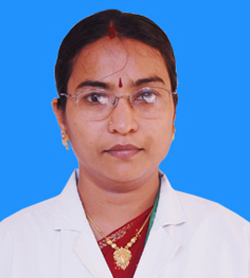
Designation | Professor
Department | Pharmaceutical Chemistry
Date of joining the institution | 19.01.98
Qualifications with Class / Grade | UG  B.Pharm  First Class | PG  M.Pharm  First Class | Ph.D  Awarded
Total Experience in years | Teaching  20 | Industry  --- | Research  09
Papers Published | National  14 | International  04
Papers Presented in Conferences | National  06 | International  ----
Ph.D Guide? Give field & University | Field  --- | University  -----
Ph.Ds / Projects Guided | Ph.Ds  --- | Projects at Masters Level  19
Books Published/ IPRs/ Patents | -----
Professional Memberships | APTI and IPhA
Consultancy Activities | -----
Awards | Best Teacher Award given by The Tamilnadu Dr.M.G.R Medical University,Chennai
Grants fetched | -----
Interaction with Professional Institutions | ------

FACULTY PROFILE- Prof. M. Senthil alias Palaniappan
Name of Teaching Staff | Prof. M. Senthil alias Palaniappan |  | 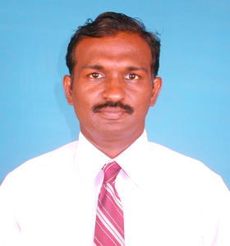
Designation | Professor
Department | Pharmaceutical Chemistry
Date of joining the institution | 01.11.1993
Qualifications with Class / Grade | UG  B.Pharm  First Class | PG  M.Pharm  First Class | Ph.D  ----
Total Experience in years | Teaching  18 | Industry  02 | Research  05
Papers Published | National  05 | International  01
Papers Presented in Conferences | National  03 | International
Ph.D Guide? Give field & University | Field  --- | University  ----
Ph.Ds / Projects Guided | Ph.Ds  --- | Projects at Masters Level  05
Books Published/ IPRs/ Patents | -----
Professional Memberships | APTI
Consultancy Activities | ----
Awards | -----
Grants fetched | -----
Interaction with Professional Institutions | -----

FACULTY PROFILE- Mr. K. Anandakumar
Name of Teaching Staff | Mr. K. Anandakumar |  | 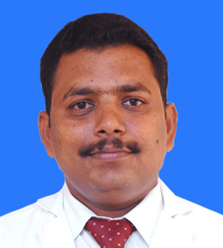
Designation | Associate Professor
Department | Pharmaceutical Analysis
Date of joining the institution | 01.09.04
Qualifications with Class / Grade | UG  B.Pharm  Second Class | PG  M.Pharm  First Class | Ph.D  --------
Total Experience in years | Teaching  12 | Industry  --- | Research  08
Papers Published | National  20 | International  04
Papers Presented in Conferences | National  05 | International  --
Ph.D Guide? Give field & University | Field  ---- | University  -----
Ph.Ds / Projects Guided | Ph.Ds  ---- | Projects at Masters Level  17
Books Published/ IPRs/ Patents | ----
Professional Memberships | APTI
Consultancy Activities | -----
Awards | -----
Grants fetched | -----
Interaction with Professional Institutions | -----

FACULTY PROFILE- Mrs. S. Shoba
Name of Teaching Staff | Mrs. S. Shoba |  | 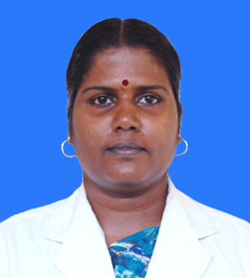
Designation | Professor in charge
Department | Pharmacology
Date of joining the institution | 22.06.2005
Qualifications with Class / Grade | UG  B.Pharm  First Class | PG  M.Pharm  First Class | Ph.D  ------
Total Experience in years | Teaching  13 | Industry  --- | Research  03
Papers Published | National  01 | International  01
Papers Presented in Conferences | National  02 | International
Ph.D Guide? Give field & University | Field  ---- | University  ----
Ph.Ds / Projects Guided | Ph.Ds  --- | Projects at Masters Level  0
Books Published/ IPRs/ Patents | ----
Professional Memberships | APTI
Consultancy Activities | -----
Awards | -----
Grants fetched | -----
Interaction with Professional Institutions | -----

FACULTY PROFILE- Dr. S. Shanmugam
Name of Teaching Staff | Dr. S. Shanmugam |  | 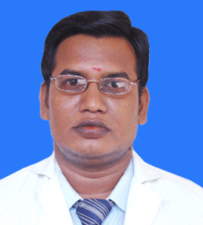
Designation | Professor
Department | Pharmaceutics
Date of joining the institution | 13.01.1999
Qualifications with Class / Grade | UG  B.Pharm  Second Class | PG  M.Pharm  First Class | Ph.D  Awarded
Total Experience in years | Teaching  14 | Industry  --- | Research  08
Papers Published | National  14 | International  06
Papers Presented in Conferences | National  02 | International  ---
Ph.D Guide? Give field & University | Field | University
Ph.Ds / Projects Guided | Ph.Ds  --- | Projects at Masters Level  12
Books Published/ IPRs/ Patents | ----
Professional Memberships | APTI, IPGA and IHPA
Consultancy Activities | ----
Awards | Rs.2000/ cash award for paper publication in Pharma buzz journal.  Best Teacher Award given by The Tamilnadu Dr.M.G.R Medical University,Chennai
Grants fetched | ----
Interaction with Professional Institutions | -----

FACULTY PROFILE- Ms. M. Vijayakumari
Name of Teaching Staff | Ms. M. Vijayakumari |  | 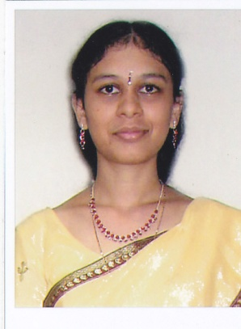
Designation | Assistant Professor
Department | Pharmacology
Date of joining the institution | 15/09/2011
Qualifications with Class / Grade | UG  B.Pharm  First Class | PG  M.Pharm  First Class | Ph.D  ------
Total Experience in years | Teaching  1.5 | Industry  --- | Research  0
Papers Published | National  01 | International  0
Papers Presented in Conferences | National  0 | International  ----
Ph.D Guide? Give field & University | Field  ---- | University  ---
Ph.Ds / Projects Guided | Ph.Ds  ---- | Projects at Masters Level  0
Books Published/ IPRs/ Patents | ----
Professional Memberships | -----
Consultancy Activities | ----
Awards | ----
Grants fetched | ----
Interaction with Professional Institutions | ----

FACULTY PROFILE- Mrs. S. Sathya
Name of Teaching Staff | Mrs. S. Sathya |  | 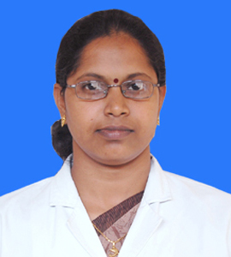
Designation | Professor incharge
Department | Pharmacognosy
Date of joining the institution | 27.09.2006
Qualifications with Class / Grade | UG  B.Pharm  Second Class | PG  M.Pharm  First Class | PhD  ------
Total Experience in years | Teaching  11 | Industry  --- | Research  05
Papers Published | National  01 | International  01
Papers Presented in Conferences | National  05 | International  ----
Ph.D Guide? Give field & University | Field  ---- | University  ----
Ph.Ds / Projects Guided | Ph.Ds  --- | Projects at Masters Level  -----
Books Published/ IPRs/ Patents | ----
Professional Memberships | APTI
Consultancy Activities | -----
Awards | -----
Grants fetched | ----
Interaction with Professional Institutions | -----

FACULTY PROFILE- Mr. T. Ayyappan
Name of Teaching Staff | Mr. T. Ayyappan |  | 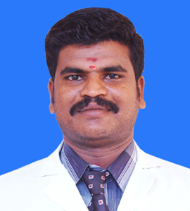
Designation | Assistant Professor
Department | Pharmaceutics
Date of joining the institution | 07.06.2004
Qualifications with Class / Grade | UG  B.Pharm  First Class | PG  M.Pharm  First Class | PhD  ------
Total Experience in years | Teaching  10 | Industry  --- | Research  06
Papers Published | National  26 | International  03
Papers Presented in Conferences | National  05 | International  ---
Ph.D Guide? Give field & University | Field  --- | University  ---
Ph.Ds / Projects Guided | Ph.Ds  ----- | Projects at Masters Level  10
Books Published/ IPRs/ Patents | ---
Professional Memberships | APTI
Consultancy Activities | -----
Awards | Rs.2000/ cash award for paper publication in Pharma buzz journal.
Grants fetched | ----
Interaction with Professional Institutions | ----

FACULTY PROFILE- Mr. A. Umar Faruksha
Name of Teaching Staff | Mr. A. Umar Faruksha |  | 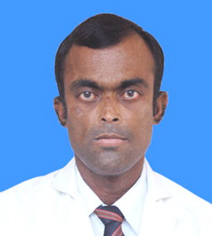
Designation | Assistant Professor
Department | Pharmaceutics
Date of joining the institution | 11.06.2007
Qualifications with Class / Grade | UG  B.Pharm  Second Class | PG  M.Pharm  First Class | Ph.D  -----
Total Experience in years | Teaching  06 | Industry  03 | Research  05
Papers Published | National  -- | International  ---
Papers Presented in Conferences | National  01 | International  ---
Ph.D Guide? Give field & University | Field  --- | University  ---
Ph.Ds / Projects Guided | Ph.Ds  ----- | Projects at Masters Level  02
Books Published/ IPRs/ Patents | ------
Professional Memberships | ------
Consultancy Activities | -----
Awards | ------
Grants fetched | ------
Interaction with Professional Institutions | -------

FACULTY PROFILE- Ms. R. Radha
Name of Teaching Staff | Ms. R. Radha |  | 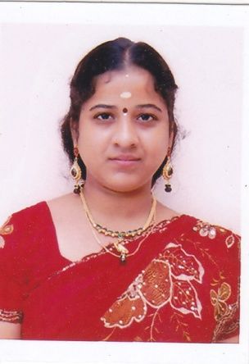
Designation | Asst Professor
Department | Pharmaceutical Chemistry
Date of joining the institution | 03/09/2012
Qualifications with Class / Grade | UG  B.Pharm  First Class | PG  M.Pharm  First Class with Distinction | Ph.D  ----
Total Experience in years | Teaching  0 | Industry  ---- | Research  02
Papers Published | National  0 | International  01
Papers Presented in Conferences | National  01 | International  ----
Ph.D Guide? Give field & University | Field  ---- | University  ------
Ph.Ds / Projects Guided | Ph.Ds  ---- | Projects at Masters Level  ----
Books Published/ IPRs/ Patents | -----
Professional Memberships | -----
Consultancy Activities | ------
Awards | -----
Grants fetched | -----
Interaction with Professional Institutions | ------

FACULTY PROFILE- Miss. T. Sangeetha
Name of Teaching Staff | Miss. T. Sangeetha |  | 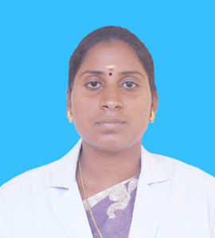
Designation | Assistant Professor
Department | Pharmacognosy
Date of joining the institution | 23.06.2008
Qualifications with Class / Grade | UG  B.Pharm  First Class | PG  M.Pharm  First Class | Ph.D  -----  ----
Total Experience in years | Teaching  5 | Industry  --- | Research  ---
Papers Published | National  03 | International  ---
Papers Presented in Conferences | National  --- | International  ----
Ph.D Guide? Give field & University | Field  ---- | University  -----
Ph.Ds / Projects Guided | Ph.Ds  --- | Projects at Masters Level  -----
Books Published/ IPRs/ Patents | ----
Professional Memberships | -----
Consultancy Activities | -----
Awards | -----
Grants fetched | -----
Interaction with Professional Institutions | -----

FACULTY PROFILE- Mrs. G. Abirami
Name of Teaching Staff | Mrs. G. Abirami |  | 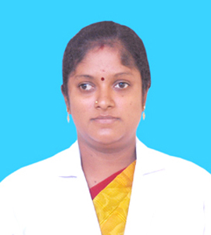
Designation | Assistant Professor
Department | Pharmaceutical Chemistry
Date of joining the institution | 02.06.2008
Qualifications with Class / Grade | UG  B.Pharm  First Class | PG  M.Pharm  First Class | Ph.D  ----
Total Experience in years | Teaching  06 | Industry  --- | Research  04
Papers Published | National  04 | International  01
Papers Presented in Conferences | National  --- | International  ------
Ph.D Guide? Give field & University | Field  ---- | University  ----
Ph.Ds / Projects Guided | Ph.Ds  ---- | Projects at Masters Level  07
Books Published/ IPRs/ Patents | -----
Professional Memberships | -----
Consultancy Activities | -----
Awards | -----
Grants fetched | -----
Interaction with Professional Institutions | -----

FACULTY PROFILE- Mr. R. Logesh
Name of Teaching Staff | Mr. R. Logesh |  | 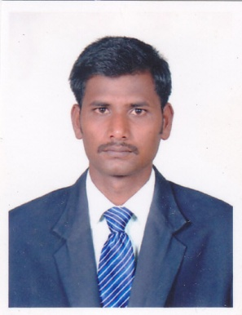
Designation | Asst Professor
Department | Pharmaceutical Chemistry
Date of joining the institution | 17/09/2012
Qualifications with Class / Grade | UG  B.Pharm  First Class | PG  M.Pharm  First Class | Ph.D  ------
Total Experience in years | Teaching  ----- | Industry  ---- | Research  ------
Papers Published | National  ------ | International  0
Papers Presented in Conferences | National  0 | International  -----
Ph.D Guide? Give field & University | Field  ---- | University  ----
Ph.Ds / Projects Guided | Ph.Ds  --- | Projects at Masters Level  ---
Books Published/ IPRs/ Patents | ----
Professional Memberships | ----
Consultancy Activities | -----
Awards | -----
Grants fetched | ------
Interaction with Professional Institutions | ------

FACULTY PROFILE- Mrs. B. Umadevi
Name of Teaching Staff | Mrs. B. Umadevi |  | 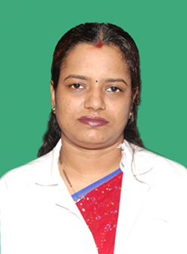
Designation | Associate Professor
Department | Pharmaceutical Analysis
Date of joining the institution | 19.09.2005
Qualifications with Class / Grade | UG  B.Pharm  First Class | PG  M.Pharm  First Class | Ph.D  ----
Total Experience in years | Teaching  10 | Industry  ----- | Research  03
Papers Published | National  01 | International  -----
Papers Presented in Conferences | National  ----- | International  -----
Ph.D Guide? Give field & University | Field  --- | University  ----
Ph.Ds / Projects Guided | Ph.Ds  --- | Projects at Masters Level  ----
Books Published/ IPRs/ Patents | ----
Professional Memberships | ----
Consultancy Activities | -----
Awards | -----
Grants fetched | -----
Interaction with Professional Institutions | -----

FACULTY PROFILE- Mr. J. Saminathan
Name of Teaching Staff | Mr. J. Saminathan |  | 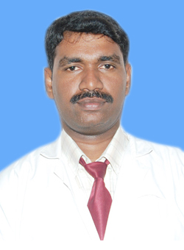
Designation | Assistant Professor
Department | Pharmaceutical Analysis
Date of joining the institution | 17.09.2008
Qualifications with Class / Grade | UG  B.Pharm  First Class | PG  M.Pharm  First Class | Ph.D  ---
Total Experience in years | Teaching  07 | Industry  ---- | Research  05
Papers Published | National  06 | International  02
Papers Presented in Conferences | National  02 | International
Ph.D Guide? Give field & University | Field  ---- | University  ----
Ph.Ds / Projects Guided | Ph.Ds  ---- | Projects at Masters Level  -----
Books Published/ IPRs/ Patents | -----
Professional Memberships | APTI and Registered pharmacist in Tamilnadu Pharmacy Council
Consultancy Activities | ------
Awards | ------
Grants fetched | ------
Interaction with Professional Institutions | ------

FACULTY PROFILE- Mr. V. Hemakumar
Name of Teaching Staff | Mr. V. Hemakumar |  | 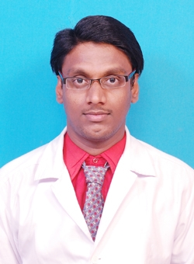
Designation | Assistant Professor
Department | Pharmaceutical Analysis
Date of joining the institution | 01.08.2008
Qualifications with Class / Grade | UG  B.Pharm  First Class | PG  M.Pharm  First Class | Ph.D  ----
Total Experience in years | Teaching  03 | Industry  --- | Research  01
Papers Published | National  ---- | International  ---
Papers Presented in Conferences | National  --- | International  -----
Ph.D Guide? Give field & University | Field  ---- | University  -----
Ph.Ds / Projects Guided | Ph.Ds  ---- | Projects at Masters Level  -----
Books Published/ IPRs/ Patents | ----
Professional Memberships | ----
Consultancy Activities | ----
Awards | ----
Grants fetched | -----
Interaction with Professional Institutions | -----

FACULTY PROFILE- Mrs. D. Kayathiri
Name of Teaching Staff | Mrs. D. Kayathiri |  | 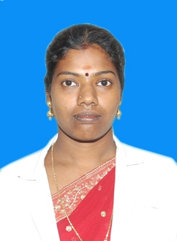
Designation | Assistant Professor
Department | Pharmaceutics
Date of joining the institution | 1.07.2003
Qualifications with Class / Grade | UG  B.Pharm  First Class | PG  M.Pharm  First Class | Ph.D  ----
Total Experience in years | Teaching  10 | Industry  ----- | Research  02
Papers Published | National  01 | International  ---
Papers Presented in Conferences | National  --- | International  -----
Ph.D Guide? Give field & University | Field  ---- | University  -----
Ph.Ds / Projects Guided | Ph.Ds  --- | Projects at Masters Level  ----
Books Published/ IPRs/ Patents | -----
Professional Memberships | APTI
Consultancy Activities | ----
Awards | ----
Grants fetched | -----
Interaction with Professional Institutions | -----

FACULTY PROFILE- Mr. K.Kamaraj
Name of Teaching Staff | Mr. K. Kamaraj |  | 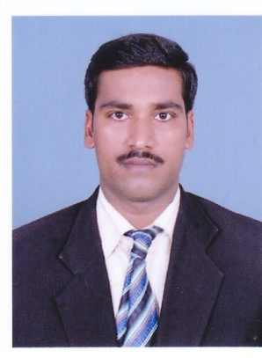
Designation | Assistant Professor
Department | Pharmaceutics
Date of joining the institution | 17/09/2012
Qualifications with Class / Grade | UG  B.Pharm  First Class | PG  M.Pharm  First Class | Ph.D  -----
Total Experience in years | Teaching  0 | Industry  ---- | Research  0
Papers Published | National  0 | International  01
Papers Presented in Conferences | National  0 | International  ----
Ph.D Guide? Give field & University | Field  ---- | University  -----
Ph.Ds / Projects Guided | Ph.Ds  --- | Projects at Masters Level  ----
Books Published/ IPRs/ Patents | ----
Professional Memberships | -----
Consultancy Activities | -----
Awards | -----
Grants fetched | -----
Interaction with Professional Institutions | -----

FACULTY PROFILE- Mr. S. Archana
Name of Teaching Staff | Ms. S. Archana |  | 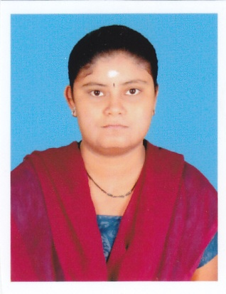
Designation | Lecturer
Department | Information Technology
Date of joining the institution | 12/09/2012
Qualifications with Class / Grade | UG  B.Sc  First Class with Distinction | PG  M.Sc  First Class with Distinction | PhD  ----
Total Experience in years | Teaching | Industry  ---- | Research  ----
Papers Published | National | International
Papers Presented in Conferences | National | International
Ph.D Guide? Give field & University | Field  ---- | University  ----
Ph.Ds / Projects Guided | Ph.Ds  ---- | Projects at Masters Level  ----
Books Published/ IPRs/ Patents | ------
Professional Memberships | -----
Consultancy Activities | ------
Awards | -----
Grants fetched | -----
Interaction with Professional Institutions | ------

FACULTY PROFILE- Mr. C. Satheesh Kumar
PART-TIME
Name of Teaching Staff | Mr. C. Satheesh Kumar |  | 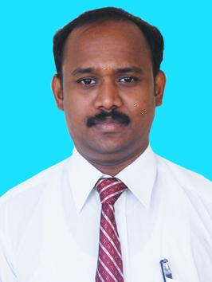
Designation | Assistant Professor
Department | Anatomy
Date of joining the institution | 01.06.2008
Qualifications with Class / Grade | UG  B.Sc | PG  MSc ( Anatomy) | Ph.D  -----
Total Experience in years | Teaching  8.6 | Industry  ---- | Research  ---
Papers Published | National  --- | International  ----
Papers Presented in Conferences | National  --- | International  -----
Ph.D Guide? Give field & University | Field  --- | University  ----
Ph.Ds / Projects Guided | Ph.Ds  ---- | Projects at Masters Level  ----
Books Published/ IPRs/ Patents | -----
Professional Memberships | -----
Consultancy Activities | -----
Awards | -----
Grants fetched | -----
Interaction with Professional Institutions | -----

14. ADMISSION QUOTA
Course | 12-13 |  |  | 11-12 |  |  |  |  | 10-11
Course | Govt. | Manage  ment | Lapsed | Govt. |  | Manage  ment |  | Lapsed | Govt. |  | Manage  ment | Lapsed
B.Pharm | 26 | 21 | 07 | 18 |  | 21 |  | 04 | 02 |  | 21 | 07
M.Pharm  (Pharm.  Analysis) | 0 | 03 | 0 | 01 |  | 03 |  | 0 | 02 |  | 07 | 08
M.Pharm  (Pharmaceutics) | 0 | 02 | 0 | 02 |  | 07 |  | 05 | 01 |  | 07 | 10
M.Pharm  (Pharm.  Chemistry) | 0 | 0 | 0 |  | 0 | 01 | 0 |  |  | 05 | 03 | 02

- Entrance test / admission criteria:
Number of seats allotted to different Test Qualified candidates separately
Government and CET - 65:35 (2012-13)
Weighted Total Marks for a Maximum of 200
Percentage in Biology (X)
Percentage in Physics & Chemistry-Taken together (Y)
Percentage in Botany & Zoology-Taken together (Z)
Weighted total marks for a maximum of 200 either (X+Y) or (Z+Y)
Add TNPPCA – HS 200 marks in Physical and Biological Sciences 100
The percentage and the weighted total will be calculated to two decimals.
The eligibility criteria for admission to B.Pharm and M.Pharm Courses offered shall be as prescribed by The T.N.Dr.M.G.R. Medical University.
Last Date for admission (2012-13) – 30.09.2012

Cut off/ last candidate admitted
Category | 12-13 | 11-12 | 10-11
Government | 111 | 92.75 | 162.00
CET/IET/Subject | 87.5 | 83.00 | 83.00
Last Candidate Admitted | S.Pushpanjali. | A.M.Abdul Raasid | E.Bhavani

Fees In Rupees
COURSE | 12-13 |  | 11-12 |  | 10-11
COURSE | Govt | Management | Govt | Management | Govt | Management
B.PHARM | 28000 | 28000 | 28000 | 28000 | 28000 | 28000
M.PHARM | 57000 | 57000 | 57000 | 57000 | 57000 | 57000

Number of Fee Waivers offered
2012-2013
Scholarship Name : Post Matric

Community: SC

1 | Anjani.S | 6360/- | Applied
2 | Devi.S | 9840/- | Applied
3 | Gururajan.C | 6360/- | Applied
4 | Gurusamy.E | 6360/- | Applied
5 | Hariharan.R | 6360/- | Applied
6 | Indumathi.P | 9840/- | Applied
7 | Tamilvani.P | 6360/- | Applied
8 | Valarmathi.D | 6360/- | Applied
9 | Ayyanar.R | 6360/- | Applied
10 | Kavitha.G | 6360/- | Applied
11 | Naveena.A | 6360/- | Applied
12 | Janarthanan.D | 6360/- | Applied
13 | Jayakumar.D | 6360/- | Applied
14 | Shobana.R | 6360/- | Applied

Community : BC

1 | Ayyamperumal.E | 1795/- | Applied
2 | Chandramoulee.G | 2200/- | Applied
3 | Dhanasri.K | 2200/- | Applied
4 | Kalaiselvi.D | 2620/ | Applied
5 | Karthiga.S | 1795/- | Applied
6 | Thangairulappan.S | 2620/- | Applied
7 | Venkatesan.M | 2200/- | Applied
8 | Bhavani.E | 1945/- | Applied
9 | Elakkiya.R | 4895/- | Applied

Community : MBC
1 | Elakkiya.R | 3180/- | Applied
2 | Magesh.S | 1795/- | Applied
3 | Rajkumar.G | 3180/- | Applied
4 | Saranraj.R | 3180/- | Applied
5 | Subashini.E | 1795/- | Applied
6 | Suganya.P | 4895/- | Applied
7 | Swathipriya.T | 4895/- | Applied

1. SC/ST Renewal/Fresh Scholarship from Government for the year
2011-2012
S.No. | Name | Amount
01 | Ayyanar.R | 8,210/-
02 | Kavitha.G | 8,210/-
03 | Subash.A | 8,210/-
04 | Naveena.A | 11,690/-
05 | Shobana.R | 8,460/-
06 | Jayakumar.D | 8,460/-
07 | Janarthanan.D | 8,460/-
08 | Manikandan.A | 8,460/-
09 | Gurusamy.A | 8,190/-
10 | Tamilvani.P | 6,160/-
11 | Anjani.S | 6,160/-
12 | Devi.S | 8,190/-
13 | Gururajan.C | 6,160/-
14 | Hariharan.R | 8,190/-
15 | Indumathi.P | 8,190/-
16 | Valarmathi.D | 6,160/-
Total |  | 1,27,560/-

2. BC/MBC Renewal/Fresh Scholarship from Government for the year
2011-2012
S.No. | Name | Amount
01 | Bhavani.E | 1795/-
02 | Elakkiya.R | 2425/-
03 | Ayyamperumal.E | 1685/-
04 | Chandra moulee.G | 1650/-
05 | Dhanasri.K | 1650/-
06 | Kalaiselvi.D | 2,070/-
07 | Karthiga.S | 1265/-
08 | Thanairulappan | 2,070/-
09 | Venkatesan.S | 2,070/-
10 | Suganya.P | 1945/-
11 | Swathipriya.T | 1945/-
12 | poonguzhali.P | 6015/-
13 | Elakkiya.R | 2630/-
14 | Magesh.S | 1265/-
15 | Rajkumar.G | 2630/-
16 | Saranraj.R | 2630/-
17 | Subashini.E | 1265/-
18 | Visalatchi.M | 2630/-
Total |  | 39,635/-

Criteria for fee waivers/scholarship – as per the Tamilnadu Govt. norms.
2010-2011
Community: SC
1 | Ayyanar.R | 6210/-
2 | Kavitha.G | 8240/-
3 | Subash.A | 6210/-
4 | Naveena.A | 8240/-
5 | Shenbagam.R | 8240/-
6 | Shobana.R | 8460/-
7 | Jayakumar.D | 8460/-
8 | Janarthanan.D | 11830/-
9 | Manikandan.D | 8460/-
10 | Sarumathi.S | 11830/-
11 | Yugambal.V | 8460/-
Community – BC
1 | Bhavani.E | 1415/-
2 | Elakkiya.R | 2295/-
Community : MBC
1 | Suganya.P | 1695/-
2 | Swathipriya.T | 1695/-
3 | Anil murugan | 2095/-
4 | Vellaisamy.M | 2095/-
5 | Poonguzhali.P | 3245/-

Calendar for admission against management/vacant seats(2012-2013):

- Last date for request for applications - 11-09-2012
- Last date for submission of application - 11-09-2012
- Dates for announcing final results - 17-09-2012
- Release of admission list (main list and waiting list should be announced on the same day
20-09-2012
- Date for acceptance by the candidate (time given should in no case be less than 15 days) - 29.09.2012
- Last date for closing of admission - 30.09.2012.
- Starting of the Academic session - 01.10.2012.
- The waiting list should be activated only on the expiry of date of main list 3.00 P.M. on 30.09.2012.
- The policy of refund of the fee, in case of withdrawal, should be clearly notified- will be refunded as per the Tamilnadu Govt. guidelines.

- PIO Quota : Not applicable

15. Infrastructural Information :

BUILDING PHOTOGRAPH-FRONT VIEW

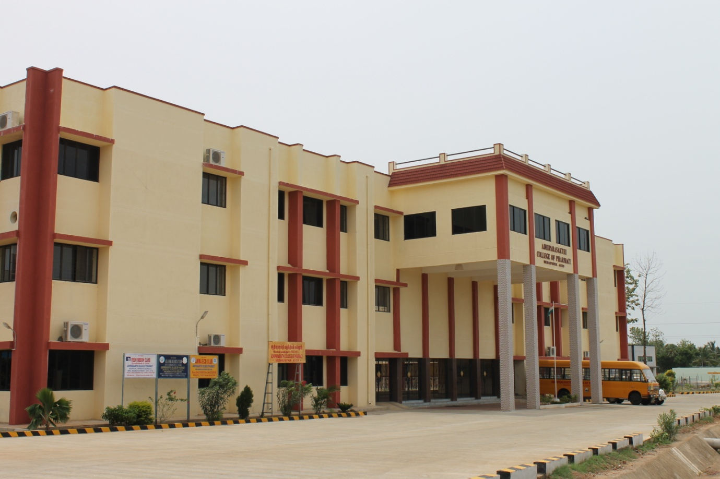

BUILDING PHOTOGRAPH-REAR VIEW

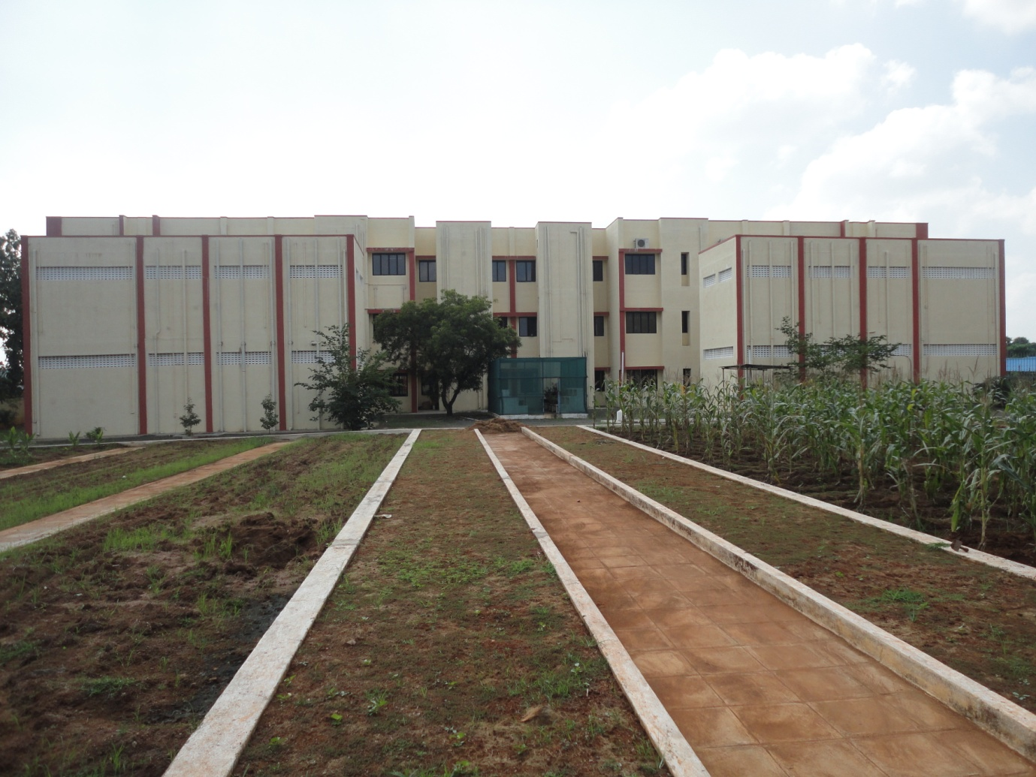

CLASSROOM/TUTORIAL ROOM FACILITIES:
CLASSROOM
B. Pharm: 4 Rooms/M. Pharm: 3 Rooms

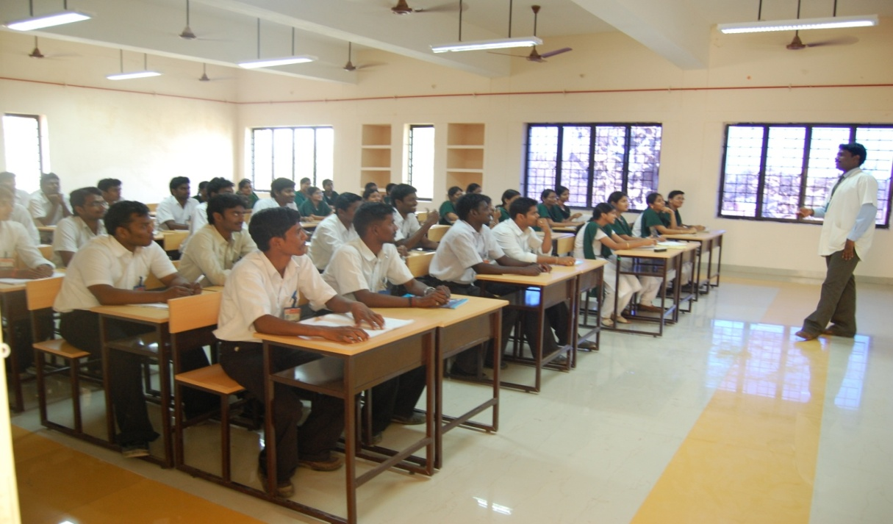

 |  | Building
1. Available Built up area per student 22.84 Sqmts.
2. Total Built up Area for the existing programme(s) : 6945 sqmts.

 | Particulars |  |  | Area required as per norms (Sq.M) | Building with RCC Roof (Sq.M) | Building with  Sheet Roof  (if suitable for Educational Institution) (Sq.M) | Total sanctioned intake (last 4 yrs. for Engg./Pharmacy/ HMCT/ Arch. etc. 2 yrs. MBA/ PGDBM and 3 yrs. for MCA) | Built up area per student | Total Area Available (Sq.M)
 | Instructional Area (Carpet Area) |  |  | 2160 | 3432 | -- | 294 | 11.67 | 3432
 | Administrative Area (Carpet Area) |  |  | 240 | 642 | -- | 294 | 2.18 | 642
 | Amenities (Carpet Area) |  |  | 480 | 1176 | -- | 294 | 4.0 | 1176
 | Circulation & Others |  |  | 854 | 2239 | -- | 294 | 7.61 | 2239
 | Total |  |  | 3734 | 7489 | -- |  | 25.46 | 7489

 |  | Instructional Area for the existing programme(s)
 | Particulars |  | Number of rooms |  | Carpet area of each room
 |  |  | Requirement as per norms | Available in the institution | Requirement as per norms | Available in the Institution (Sq.M)
 | Class Rooms |  | 3+3 | 7 | 6x66 | 879
 | Tutorial Hall |  | 3 | 3 | 3x36 | 162
 | Drawing Hall (*) |  | - | - | - | --
 | Computer Centre |  | 1 | 1 | 75 | 150
 | Library |  | 1 | 1 | 150 | 240
 | Laboratories & workshops |  | 13 | 17 | 1450 | 2061
 | Total |  | 24 | 29 | 2179 | 3492

Laboratory DETAILS : TOTAL LAB-20 No’s

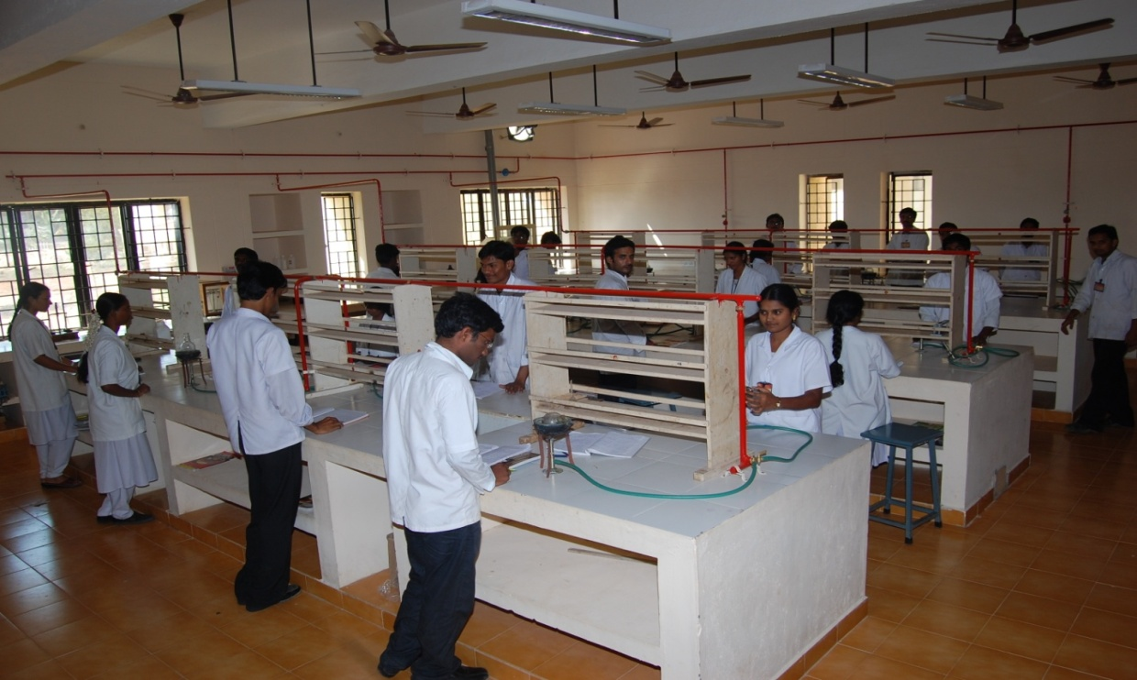

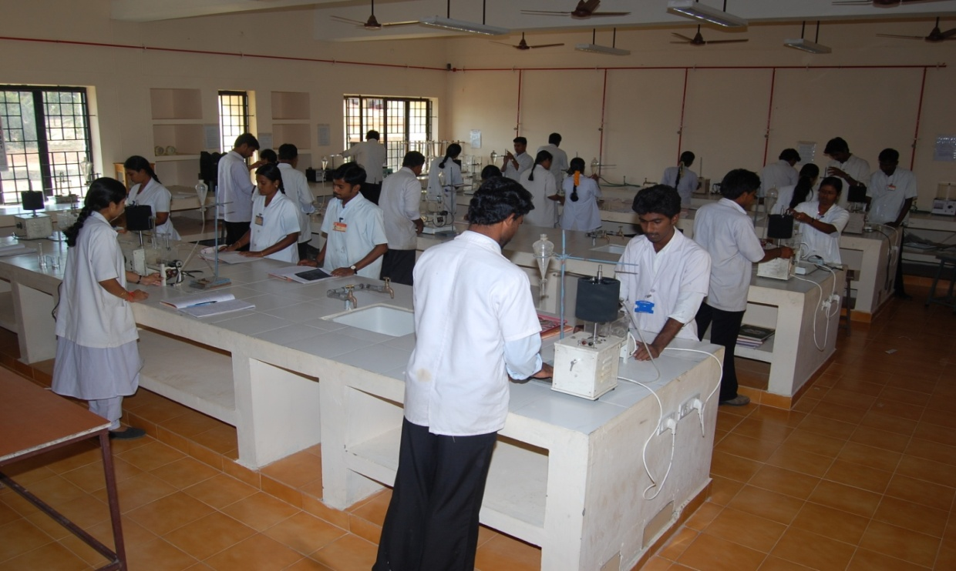

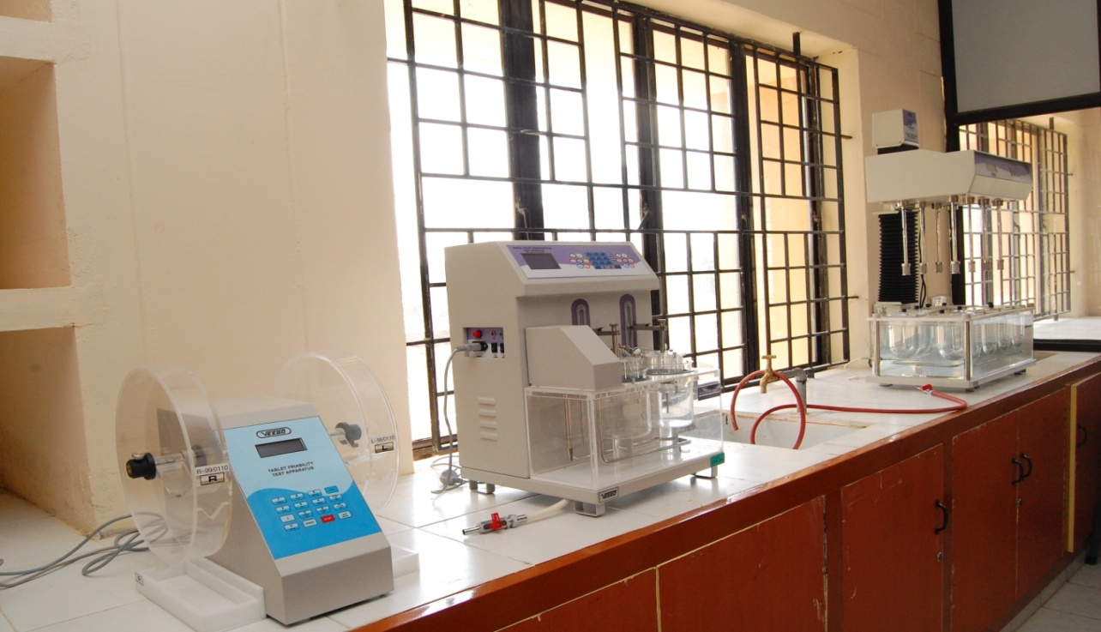

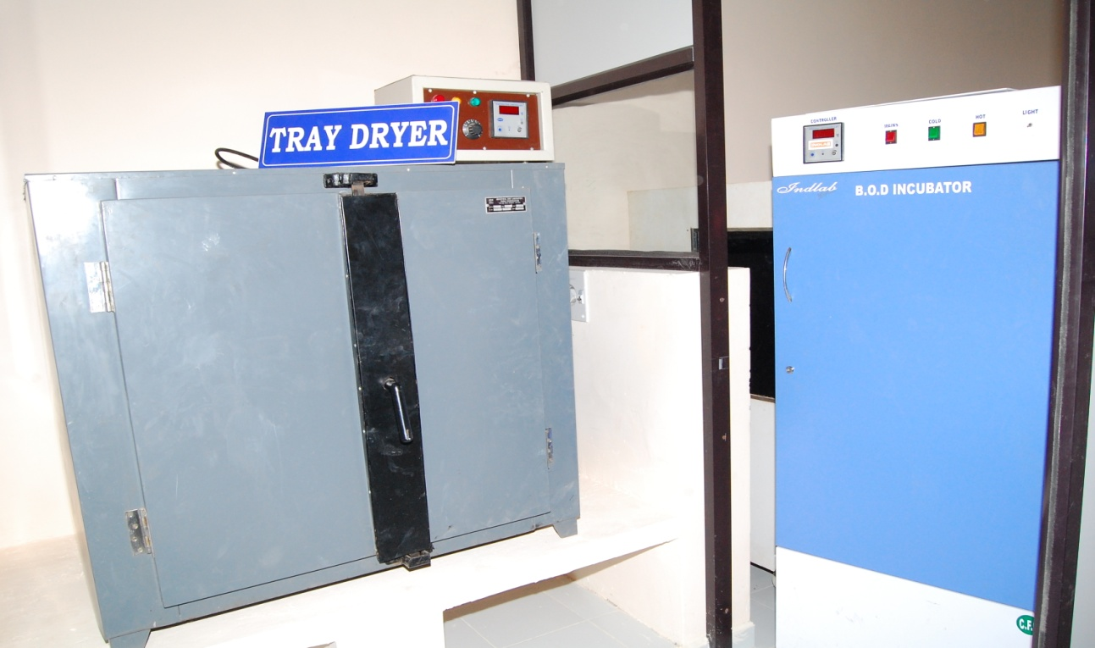

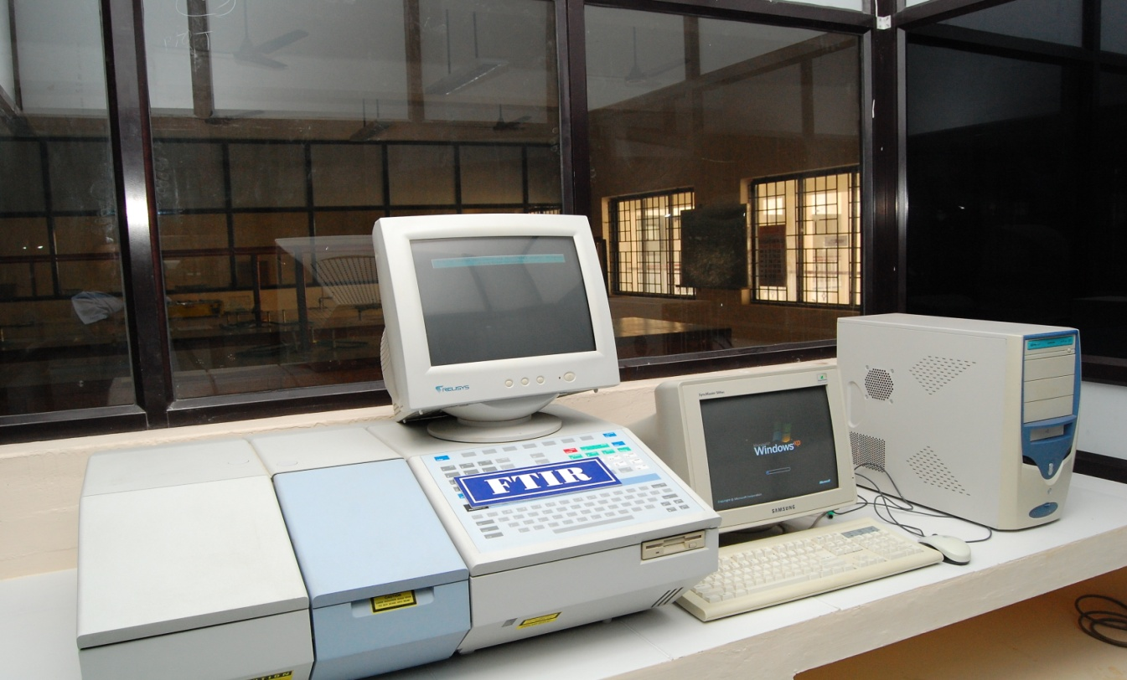

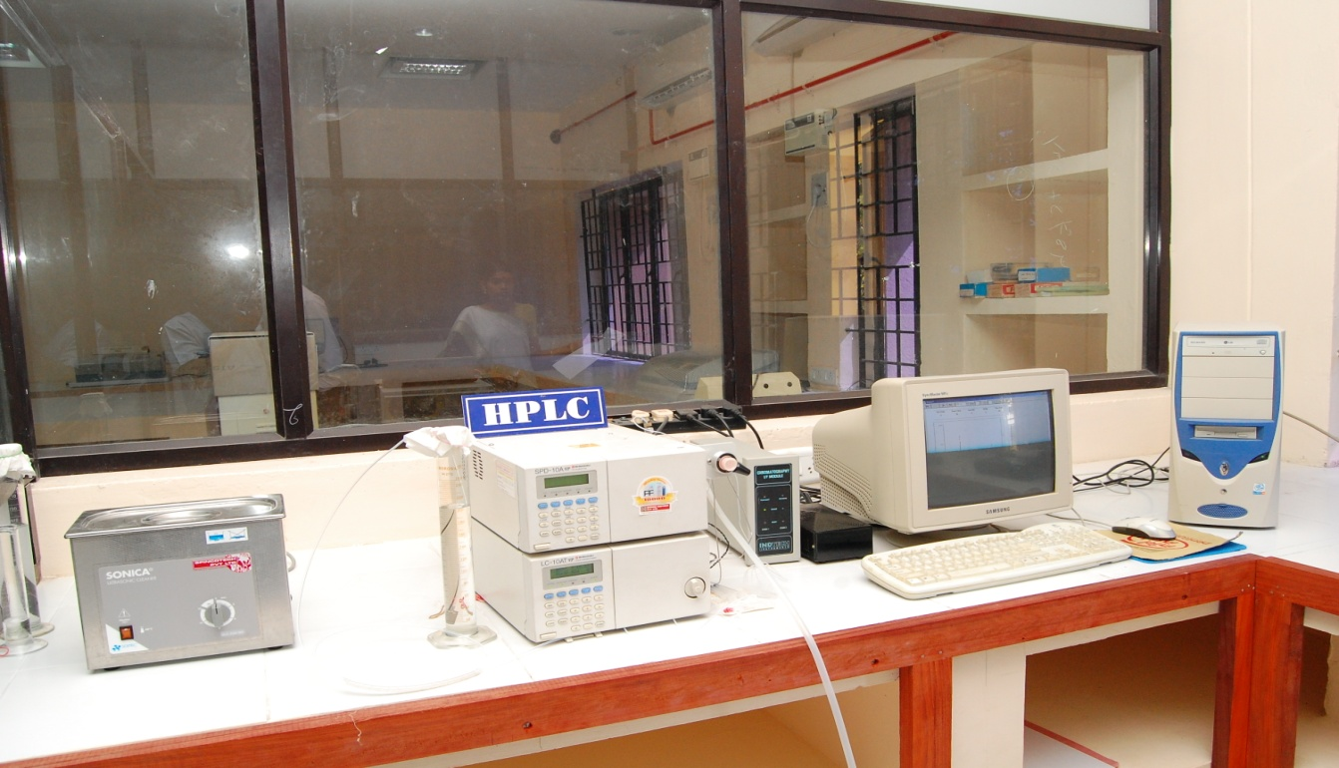

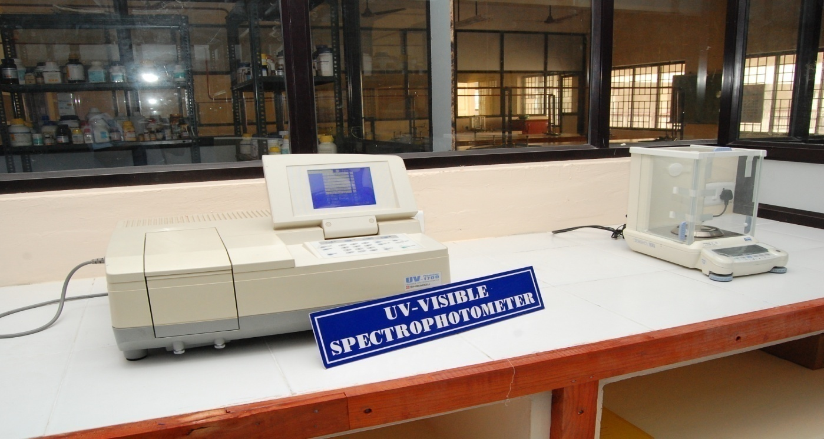

COMPUTER CENTRE FACILITIES:
S.No | Particulars | Requirements as per Norms (1:4 for Engg., 1:6 for Pharmacy/ HMCT/Arch./ Applied Arts and 1:2 for MBA/MCA) |  | Availability
1. | No of Computer terminals | 40 |  | 64
2. | Hardware Specification | P-IV |  | P-IV : 60, P-III : 04
3. | No of terminals of LAN/WAN | 20 |  | 34
4. | Relevant Legal Software | Application  04 | System  02
 |  |  |  | 10 | 05
5. | Peripheral(s)/ Printers | 05 |  | 05 | 64
6. | Internet Accessibility (in kbps & hrs) | Not specified |  | Broad-Band internet facility available

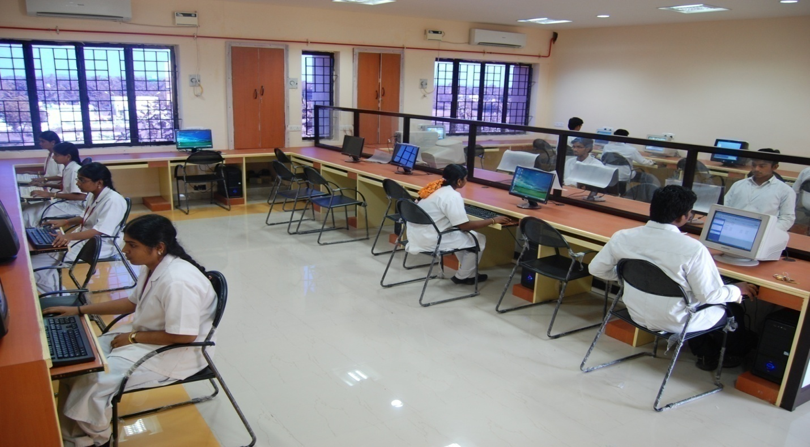

Library FACILITIES:

S.  No | Course(s) | Number of titles of the books  - | Number of volumes | Number of Journals
 |  |  |  | National | International
1 | B.Pharm | 1412 | 6324 | 12 | 12
2 | M.Pharm | 563 | 4076 | 14 | 10

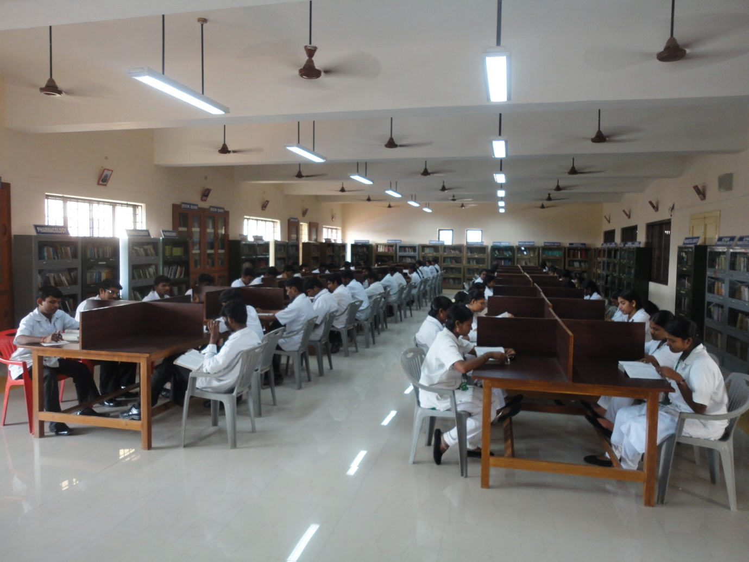

AUDITORIUM/SEMINAR HALLS :
Auditorium – 1
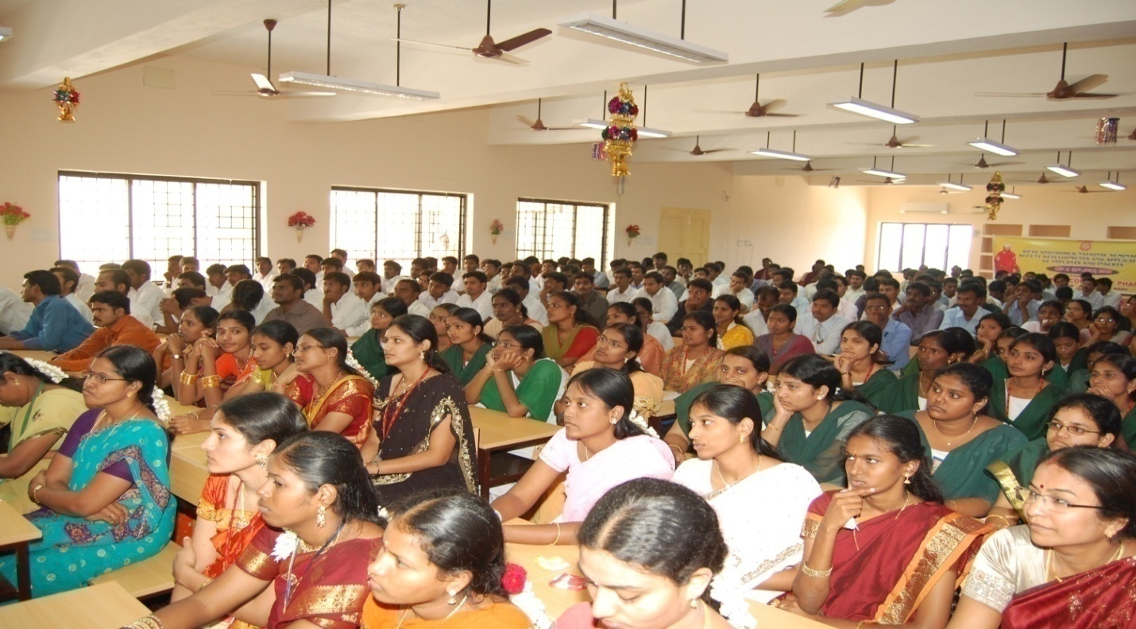
Seminar Hall - 1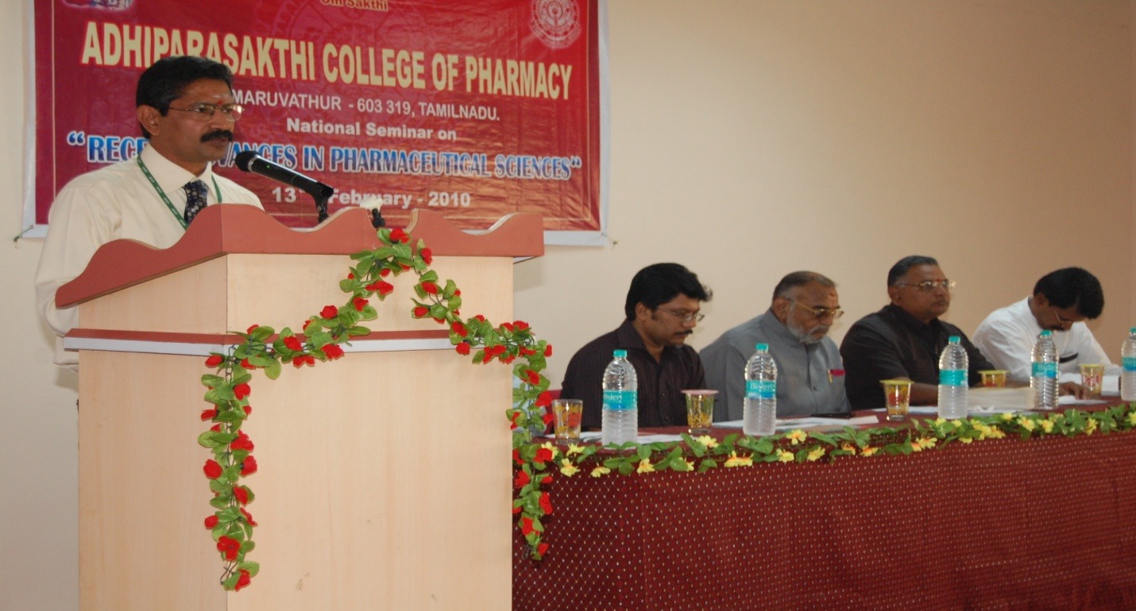

CAFETERIA

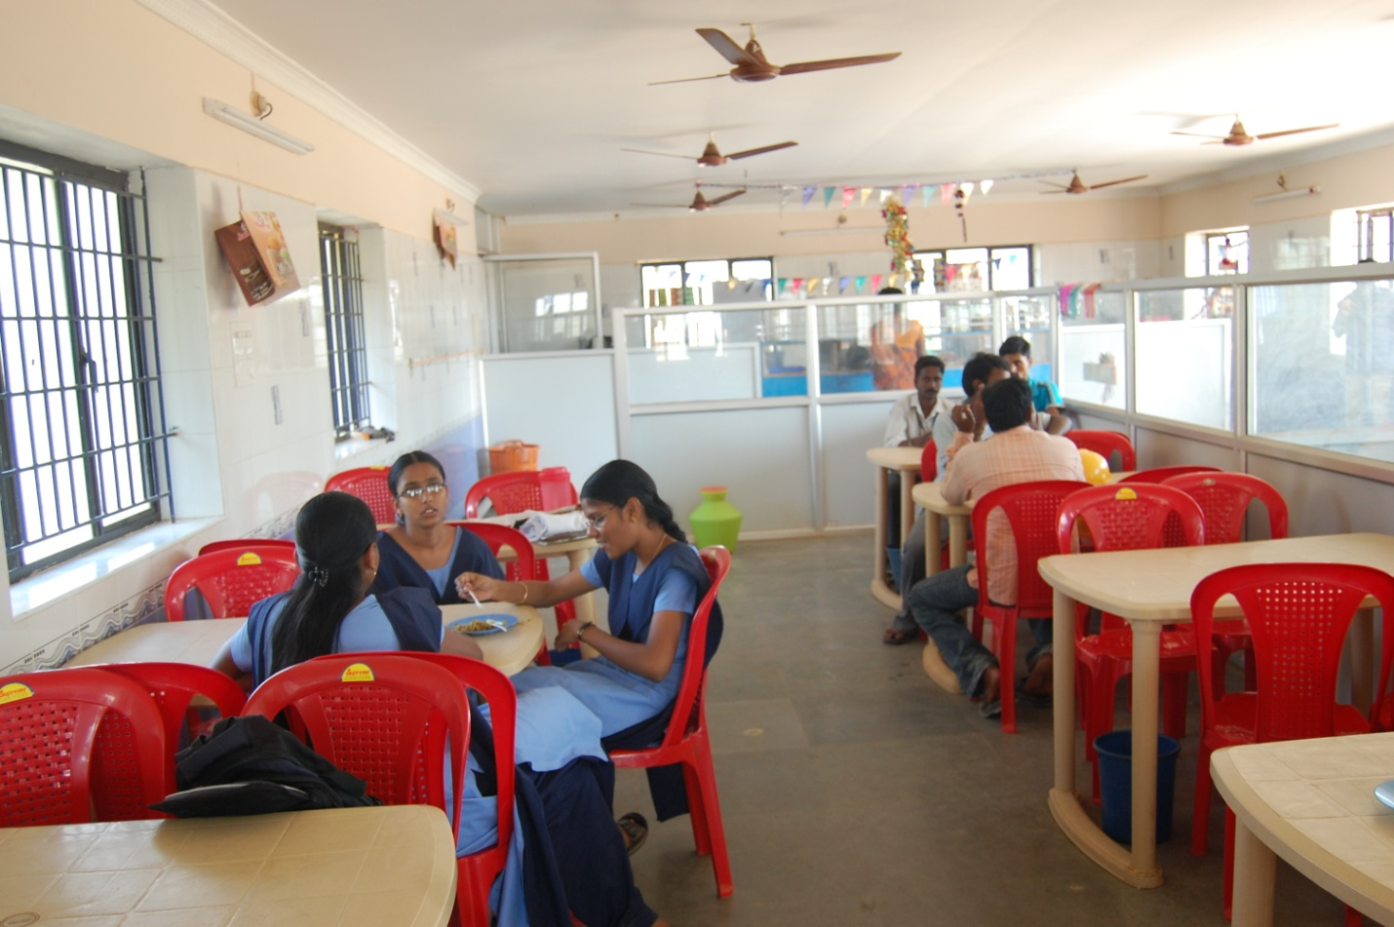

INDOOR SPORTS FACILITIES :
Carom board, Chess & Table tennis

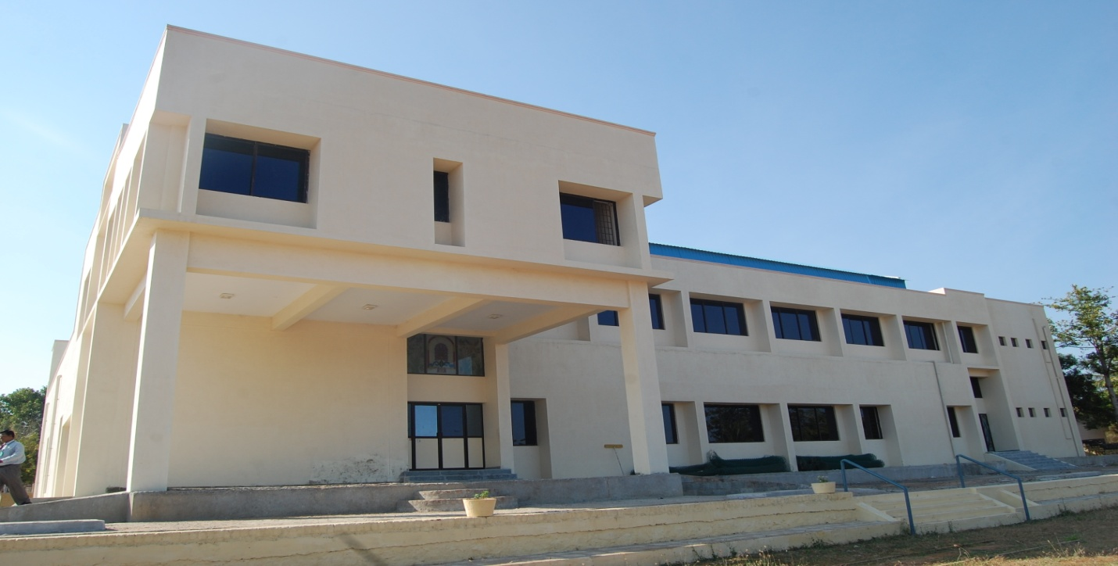

OUTDOOR SPORTS FACILITIES : Vollyball , Basketball , Cricket, Football & tennis
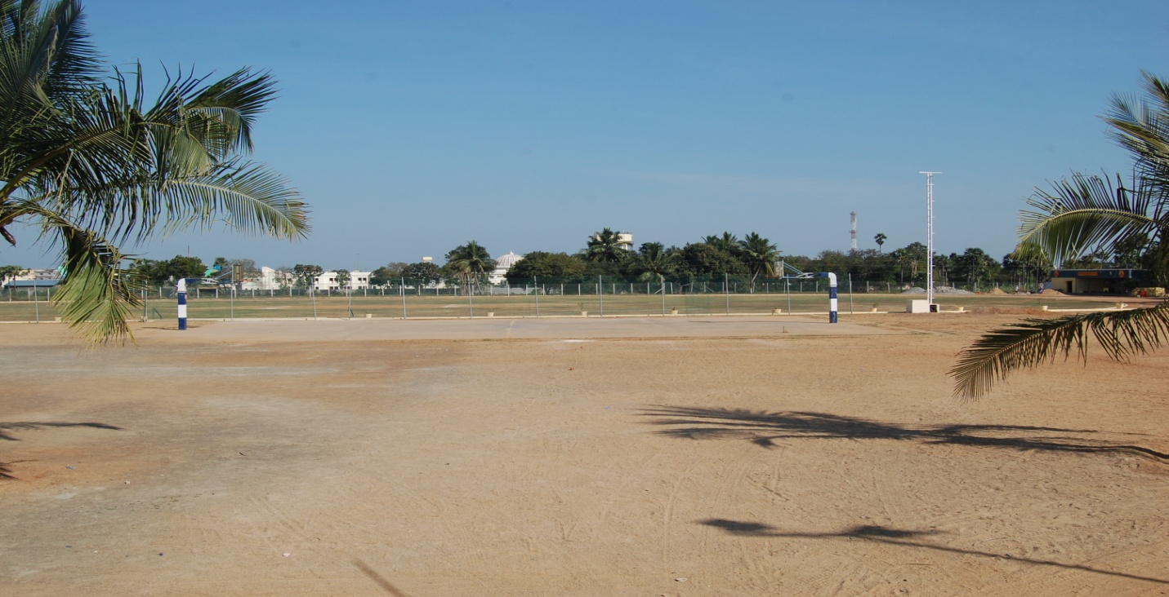

GYMNASIUM FACILITIES :
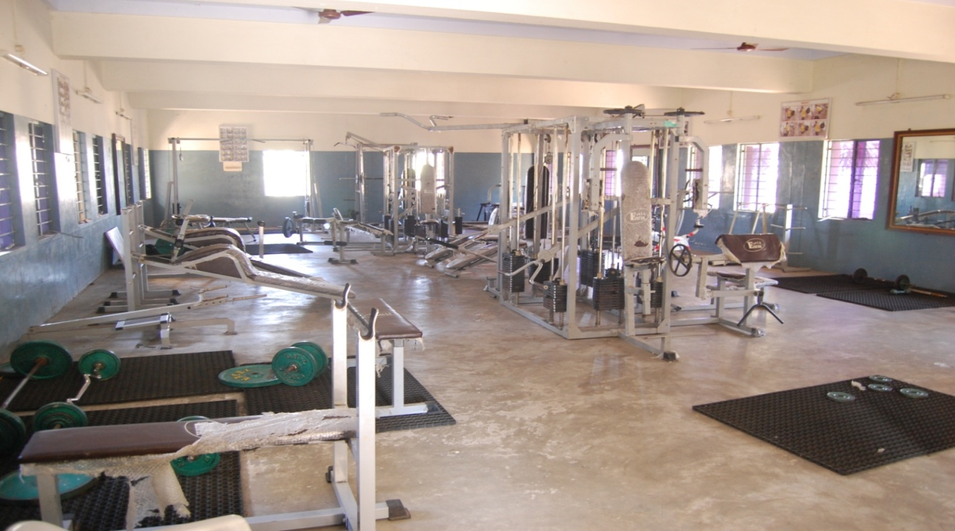

FACILITIES FOR DISABLED : Transport Facility and Providing wheelchairs etc 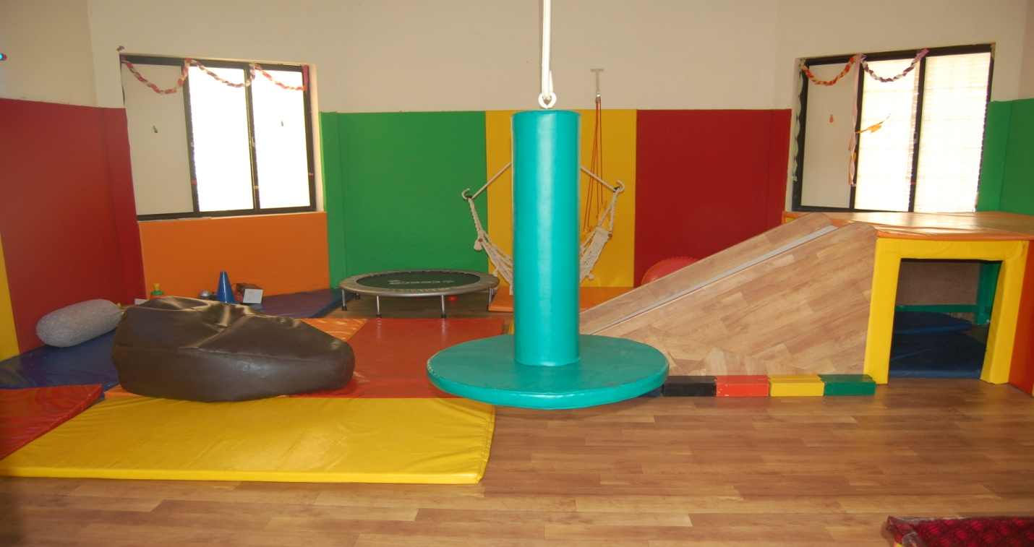

ANY OTHER FACILITIES : Generator facilities --------KVA-, transport facilities
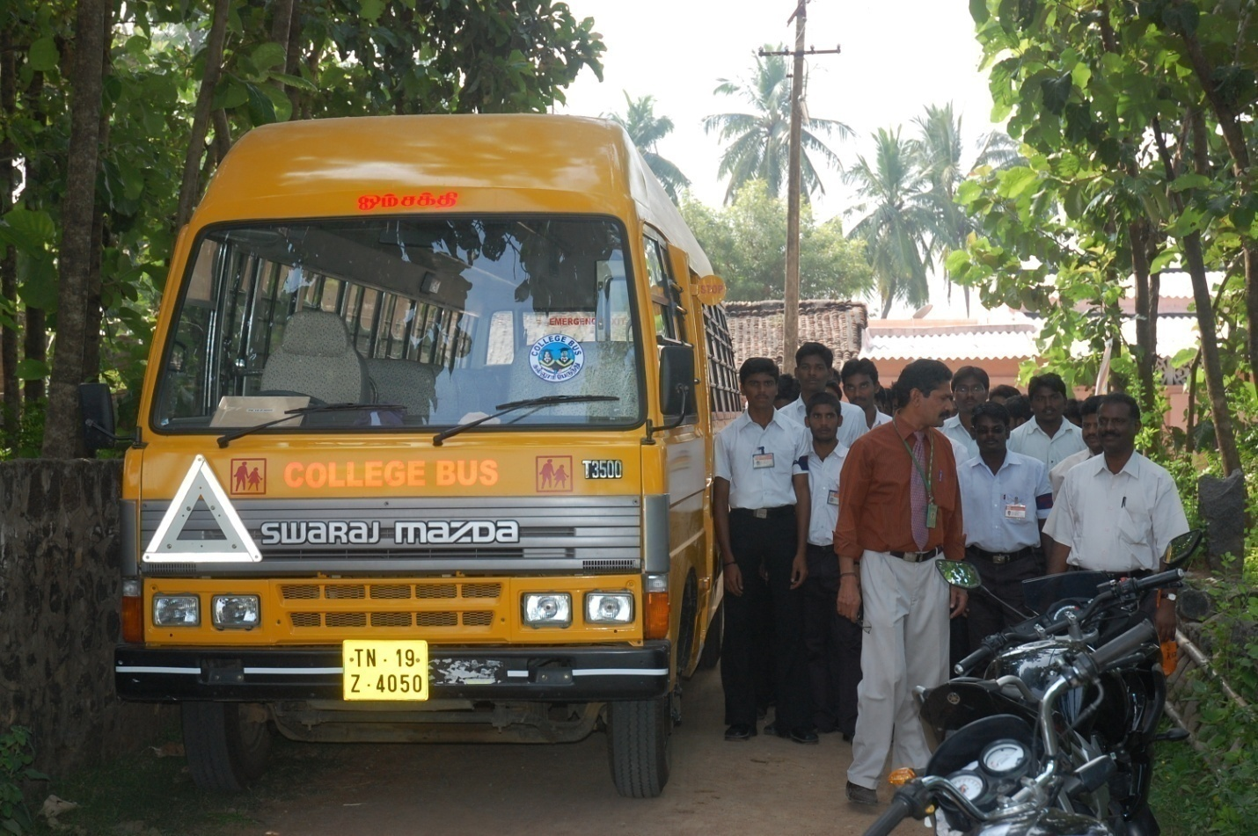

16. BOYS HOSTEL: The College runs both Gents Hostel and Ladies Hostel separately with good atmosphere
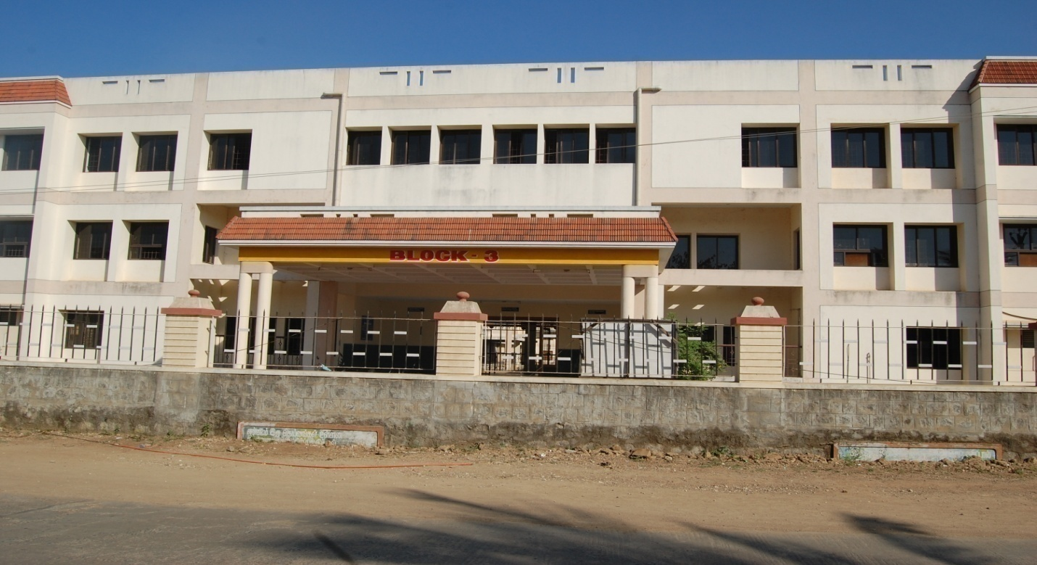

GIRLS HOSTEL:
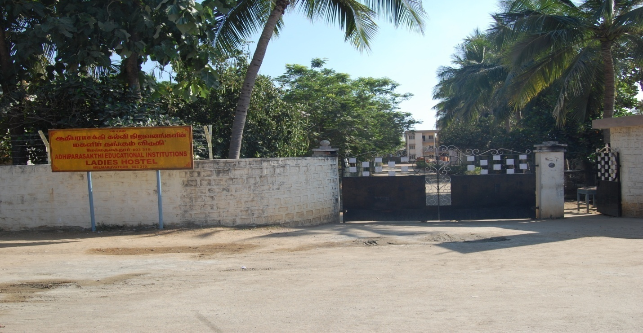

MEDICAL AND OTHER FACILITIES AT HOSTEL:
The health care centre facilities, at free of cost for the students are catered to
MAPIMS Medical College, a multi facility hospital which is nearby hostel for both boys and girls
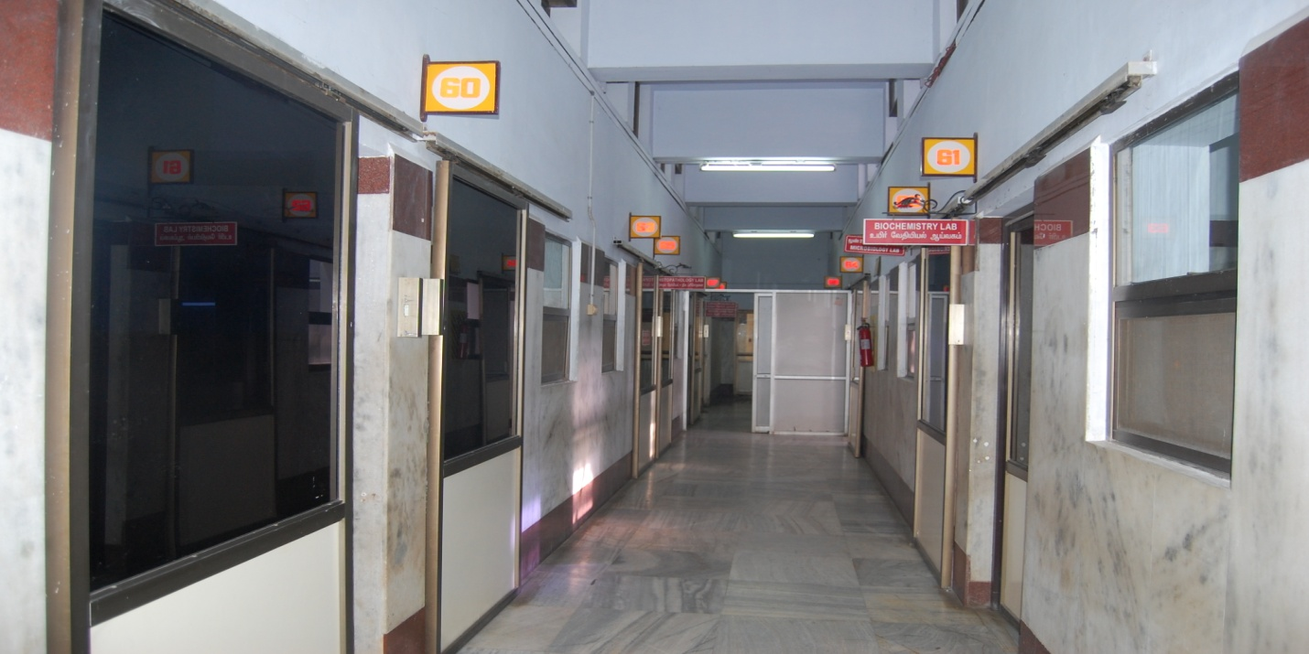

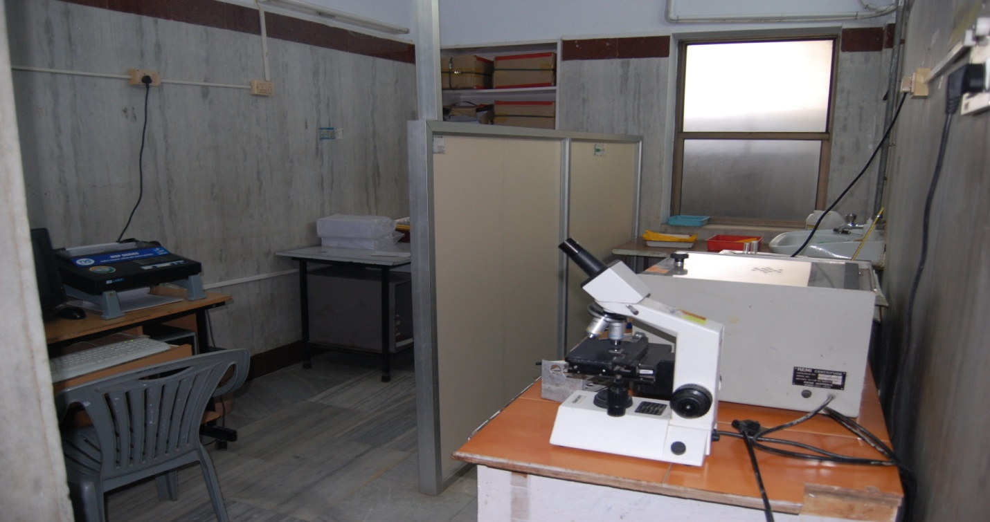

OTHER FACILITIES AT HOSTEL:
- Well – equipped hydraulic gym
- Indoor games like table tennis, carom, and chess
- Recreation hall with T.V and audio system
- Reading room comprising common magazines and news papers.
- STD booth, stationary store and dry cleaning facilities are also available.
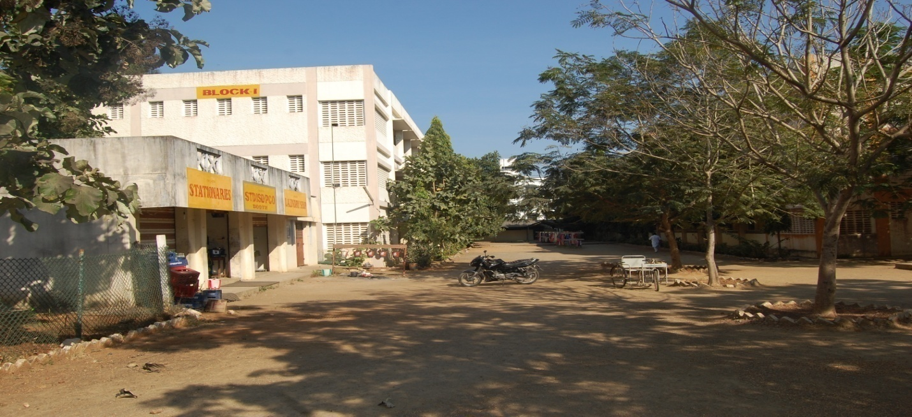

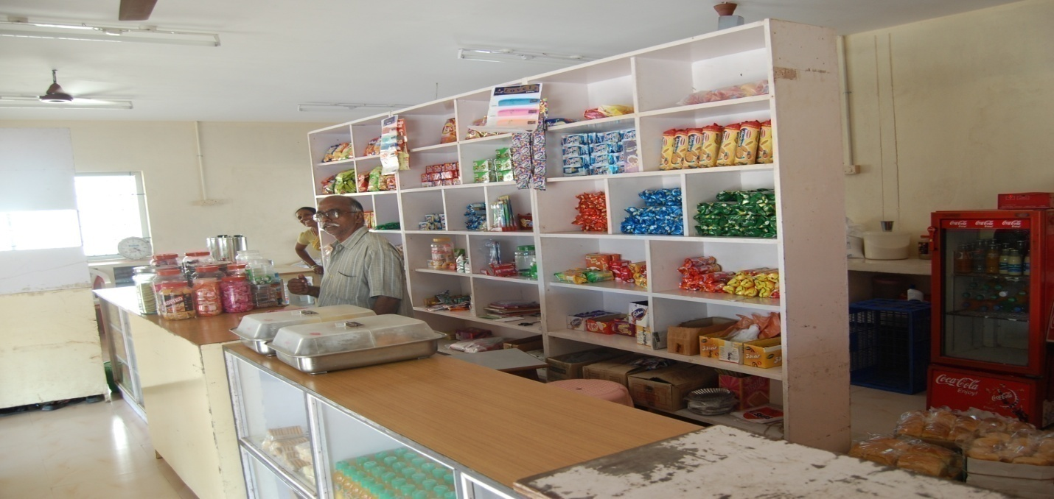

17. Academic Session B.Pharm- October 2012 to September 2013
M.Pharm-May 2012 to April 2013

Examination system, year/sem : Year wise system
Periodic declaration of results : B.Pharm- September - 2013
M.Pharm – May - 2013
18. Counseling/mentoring: Slow readers are identified by the mentors and the counseling is provided to clear all subjects in first attempt itself and special coaching also provided for the uplift of rural youth.
Career counseling: 45 Days training provided at manufacturing units and thereby placement is more for our students.
Medical facilities:Physically and Mentally weaker students are identified and the counseling is provided by the counseling members and necessary medical facilities is also provided at our Medical College Hospital.
Students insurance: Yes, implemented
19. STUDENTS ACTIVITY BODY:
CULTURAL ACTIVITIES: Convener : Dr.T.Vetrichelvan
Co-ordinator-Mrs.S.Sathya, Asst. Professor
Members: 1. Miss.R. Aswini
2. Ms.R. Elakkiya.
3. Mr.G. Rajeshkanna
4. Mr.S. Suresh.

SPORTS ACTIVITIES: Convener : Dr.T.Vetrichelvan
Co-ordinator-Mr.A.Umar Faruk Sha, Asst. Professor
Members: 1. Mr.D. Janarthanan
2. Mr.B. Anbumani.
3. Mr.K. Jaiasankar.
4. Mr.P. Killivalavan.

LITERARY ACTIVITIES: Convener : Dr.T.Vetrichelvan
Co-ordinator-Mr.J.Saminathan, Asst. Professor
Members: 1. Miss.E.Deepa.
2. Miss.G.Kokila.
3. Ms.N.Meharaj
4. Mr.V. Raja.

MAGAZINE/NEWSLETTER: Convener : Dr.T.Vetrichelvan
Co-ordinator-Mr.T.Ayyappan, Asst. Professor
Members: 1. Mr.R.Suresh
2. Miss.T.Swathipriya.
3. Miss.R. Vijayalakshmi.
4. Miss.K. Vijayalatha.

TECHNICAL ACTIVITIES: Convener : Dr.T.Vetrichelvan
Co-ordinator-Mr.K.Ananda Kumar, Asst. Professor
Members: 1. Miss.S.Revathi
2. Miss.P.Suganya
3. Mr.N. Saravanaraj.
4. Mr.A.Ramdass.

INDUSTRIAL VISITS TOUR: Convener : Dr.T.Vetrichelvan
Co-ordinator-Dr.S.Shanmugam, Professor
Members: 1. Mr.M.Balasundaresan.
2. Mr.J.Arunprasad.
3. Mr.S.Manogar.
4. Ms.Padduri surekha.

ALUMNI ACTIVITIES: Alumni contribute significantly to develop the institution in the following ways.
- They volunteer readily by donating text books, to their Junior students.
- They guide the outgoing students in their career opportunities.
- They render financial assistance to some of the students.
- They provide suggestions to improve infrastructure, academic programs and various other activities.
- Providing samples while conducting extension activities

20. Name of the information officer for RTI: : Dr.T.Vetrichelvan
Designation : Professor and Principal
Phone Number with STD Code : 044/27529093
FAX Number with STD Code : 044/27529196
Email : vetrisel@yahoo.com

For each Laboratory
- List of Major Equipment/Facilities
LIST OF EQUIPMENTS & MACHINERY ETC., REQUIRED FOR CONDUCT
OF ENTIRE B.PHARMACY DEGREE COURSE
S.No. | EQUIPMENTS & INSTRUMENTS | No. AVAILABLE
 | PHARMACEUTICS
 | Ampoule Filling and Sealing Machine | 1
 | Ampoule Washing Machine | 1
 | Autoclave | 2
 | Blender | 2
 | Continuous Hot Extraction Equipment | 7
 | Conical Percolator | 30
 | Tincture Press | 1
 | Hand Grinding Mill | 5
 | Disintegrator | 1
 | Ball Mill | 1
 | Tablet Punching Machine and Rotary Tablet Punching Machine | 2&1
 | Tablet Coating Pan Unit with Hot Air  Blower Laboratory | 1
 | Polishing Pan Laboratory Size | 1
 | Tablet Hardness Tester (Monsanto Type) | 5
 | Tablet Hardness Tester (Pfizer Type) | 3
 | Disintegration Test Unit | 1
 | Disintegration Test Unit ( DIGITAL) | 1
 | Dissolution Rate Test Apparatus (1 STAGE) | 2
 | Dissolution Rate Test Apparatus (6 STAGE) | 1
 | Dissolution Rate Test Apparatus (8 STAGE) | 1
 | Granulating Sieve Set | 25
 | Tablet Counter Small size | 5
 | Friability Tester | 1
 | Friability Tester ( DIGITAL) | 1
 | Collapsible Tube Filling and Sealing Equipment | 2
 | Capsule Filling Machine (laboratory Size) | 2
 | Prescription Balance | 40
 | Balance Torsion type with removable glass pan  Sensitivity 30 mgm | 5
 | Dissolution equipment for Distilled Water | 2
 | Water Deionization | 1
 | All Glass Distillation Unit for making water  for Injection | 2
 | Sintered Glass filters for Bacteria  Proof Filteration (4 different grades) | 20 of each grades
 | Millipore Filters 3 grades | 20 of each grades
 | Pressure Cooker | 5
 | Hot Air Sterilizer | 2
 | Incubator | 2
 | Aseptic Cabinet | 2
 | Rabbit Cages and Holder | 20
 | Ampoule clarity Test Equipment | 2
 | Sieves set (Pharmacopoeial Standard) | 10
 | Laboratory Centrifuge | 2
 | Ointment Slab | 60
 | Ointment Spatula | 50
 | Pestle and Mortar (Porcelain) | 50
 | Pestle and Mortar (Glass) | 30
 | Suppository Mould of 3 Sizes | 20 each
 | Refrigerator | 1
 | Rotary Vacuum Evaporator | 1
 | Electrical bath (12 holes) | 1
50. | General Glasswares | Adequate
51. | Chemicals, appliances and Laboratory facilities | Adequate
 | PHARMACEUTICAL CHEMISTRY
- . | Analytical Balance & Weight Box set | 40
 | Atomic Model Set | 4
 | Dhona Electronic Balance | 1
 | Refractrometer | 1
 | Polarimeter | 1
 | Photo Electric Colorimeter | 1
 | pH Meter | 3
 | Physical Balance & Weight Box set | 40
 | Periodic Table Chart | 2
 | Flame Photometer | 1
 | Melting Point Apparatus | 1
 | U.V. Visible Spectrophotometer single beam | 2
 | U.V. Visible Spectrophotometer double beam | 2
 | Nephelometer | 1
 | Platform Balance | 2
 | Karl Fischer Titrator | 2
 | Conductivity Meter | 1
 | Fuming Cupboard | 2
 | Kipp’s Apparatus | 2
 | Thermostatic Bath | 2
 | Oven | 1
 | HPLC | 1
 | De-ioniser | 1
 | Electrophoresis | 1
 | Spectrofluorimeter | 1
 | Fluorimeter (Elico) | 1
27. | General Glasswares | Adequate
28. | Miscellaneous Appliances, Chemicals  and Laboratory Facilities | Adequate
 | PHARMACOLOGY,ANATOMY AND PHYSIOLOGY
 | Aerator | 20
 | Haemoglobinometer | 20
 | Haemocytometer | 10
 | Student’s Organ Bath | 10
 | Sherrington Rotating Drum | 10
 | Smoking stand | 2
 | Smoking burner | 2
 | Tray (Dissecting) | 15
 | Frontal Writing Lever | 15
 | Frog Board | 30
 | Tele Thermometer | 1
 | Pole Climbing Apparatus | 1
 | Histamine Chamber | 1
 | Simple Lever | 18
 | Sterling Heart Lever | 10
 | E.C.G. Machine | 1
 | Aeration Tube | 20
 | Histological Slide | 30
 | Sphygmomanometer (B.P. Apparatus) | 7
 | Stethoscope | 15
 | First aid Equipment | 5 Sets
 | Contraceptive Device | 5 Sets
 | Dissecting (Surgical) Instrument | 20 Sets
 | Operation Table (small) | 2
 | Balance for Weighing small animals | 2
 | Kymograph Paper | Adequate
 | Activity Cage (Actophotometer) | 1
 | Analgesiometer (Tail flick) | 1
 | Analgesiometer (Eddy’s hot plate) | 2
 | Thermometer | 30
 | Distilled Water Still | 2
 | Plastic Animal Cage | 25
 | Double Unit Organ Bath with Thermostat | 1
 | Refrigerator | 1
 | Single Pan Balance | 1
 | Chart | Adequate
 | Human Skeleton | 1
 | Anatomical Specimen (Heart, Brain, Eye,  Ear and reproductive system etc.) | 1 Set
 | Electro-Convulsiometer | 1
 | Stop Watch | 10
 | Clamp, Bossheads, Screw Clips | Adequate
 | Symes Cannula | 20
43. | General Glassware | Adequate
44. | Chemicals and Misc. Laboratory, Apparatus and Appliances (Needles  Thread, Plastician, Tubing, PolytheneTubes, Syringes etc.) | Adequate
 | PHARMACOGNOSY
1 | Aseptic Cabinet | 1
2 | Dissecting Microscope | 20
3 | Chart (Different Types) | 100
4 | Models (Different Types) | 50
5 | Permanent Slides | 100
6 | Slides and Cover Slip | Adequate
7 | Muffle Furnace | 5
8 | Silica Crucible | 7
9 | Camera Lucida | 17
10 | Oven | 1
11 | Incubator | 1
12 | Grinding Machine | 2
13 | Pulveriser | 1
14 | Soxhlet Apparatus | 3
15 | Laminar Air Flow Chamber | 1
16 | Eyepiece & Stage Micrometer | 20
17 | Desiccator | 1
18 | Chemical Balance | 2
19 | Refractometer | 1
20 | Polarimeter | 1
21 | General Glassware | Adequate
22 | Misc. appliances, Chemicals and  Laboratory facilities | Adequate
 | BIOCHEMISTRY
1 | Colorimeter | 2
2 | Microscope | 20
3 | Centrifuge | 1
4 | Watch Glass | 30
5 | Microscope with Oil Immersion | 5
6 | Permanent Slides (Skin, Kidney, Liver etc.) | Adequate
7 | General Glass wares | Adequate
8 | Biochemical reagents for analysis of  Normal and pathological constituents  Of urine and blood facilities | Adequate
 | HOSPITAL & CLINICAL PHARMACY
1 | Autoclave Sterilizer | 2
2 | Mixing Vat with Stirrer | 2
3 | Water Still | 1
4 | Filling Machine | 1
5 | Filtration Equipment | 2
6 | Sealing Machine | 1
7 | pH Meter | 1
8 | Membrane Filter | 1 Unit
9 | Sintered glass funnel with complete  Filtering assembly | 10 Unit
10 | Small Disposable membrane filter for IV  Admixture filtration | Adequate
11 | Laminar Air Flow bench | 1
12 | Vacuum Pump | 1
13 | Oven | 2
14 | Surgical dressing | Adequate
15 | Incubator | 1
16 | Karl Fischer Apparatus for Moisture  Content Determination | 2
17 | Flame Photometer | 1
18 | Dissolution Apparatus | 1
19 | Disintegration Test Apparatus | 1
20 | Hardness Tester | 3
21 | Centrifuge | 1
22 | Magnetic Stirrer | 1
23 | Thermostatic Bath | 1
24 | Antibiotic Zone Reader | 1
25 | Colony Counter | 1
26 | Experimental Animals | Adequate
27. | OHP with Teaching Aids | 1
28. | Slide Projector | 1
 | General List of Equipments
1 | Distilled water still | 2
2 | Vacuum pump | 2
3 | Refrigerator | 1
4 | Compound Microscope | 20
5 | Slide cum strip projector | 1
6 | Over head Projector | 4
7 | Project Screen | 2
8 | Shimadzu Balance | 12
9 | General glass wares, chemical reagents and Miscellaneous appliances | Sufficient

Museum: Maintained a museum of crude drugs, herbarium sheets, botanical specimens of the drugs and
Plants mention in the course. In addition, the following are recommended:
1. Colored slides of medicinal plants
2. Display of popular patent medicines and
3. Containers of common usage in medicines
- List of Experimental Setup
Synthesis of Drugs → Elucidation → Analytical Studies → Biological Activities
Formulations → Analytical Studies → Invivo/Invitro studies
Microscopical studies → Isolation and Purification of Phytoconstituents
→ Elucidation → Biological activities

